

**FUNCTIONAL AND TECHNICAL PRESENTATION**

**Table of contents**

1. FUNCTIONAL PRESENTATION 3

1.1. Principle 3

1.2. Type of data collected from devices 4

2. TECHNICAL PRESENTATION 5

2.1. Focalist® architecture 5

2.2. Ports used in the internal network 5

2.3. Characteristic of connection between Focalist® Agent and Doxense® Cloud 6

2.4. Information queries by the monitoring agent 6

Discovery Cycle 7

Meter and Supply Cycle 7

Alert Cycle 8

© 2019. Doxense®. All rights reserved.

**Copyrights**

Focalist and all product names or trademarks mentioned in this document are tra- demarks of their respective owners.

Reproduction in whole or part, by any means whatsoever is prohibited without prior authorisation. Any electronic copies, either by photocopy, photograph, film or any other means is an offense.

47, avenue de Flandre 59290 Wasquehal - FRANCE [contact@doxense.com](mailto:contact@doxense.fr)

Tel : +33(0)3.62.21.14.00

Fax : +33(0)3.62.21.14.01

[www.doxense.com](http://www.doxense.com/)

Update : 24 april 2024

# FUNCTIONAL PRESENTATION

## Principle

Focalist® is a solution in the SaaS model which helps in managing printers, consu- mables, and malfunctions.

The main functionalities of Focalist®:

allows to trace the complete process of handling supplies from the moment of shipping to be exchanged, providing precise data concerning printed pages and usage graphs;

automates accounting the number of printed pages and printing costs; detects automatic malfunctions and recognizes their type;

determines whether in order to repair the broken device it is necessary to call for specialist service, the module for accounting the service allows to estimate the time and costs of fixing the problem.

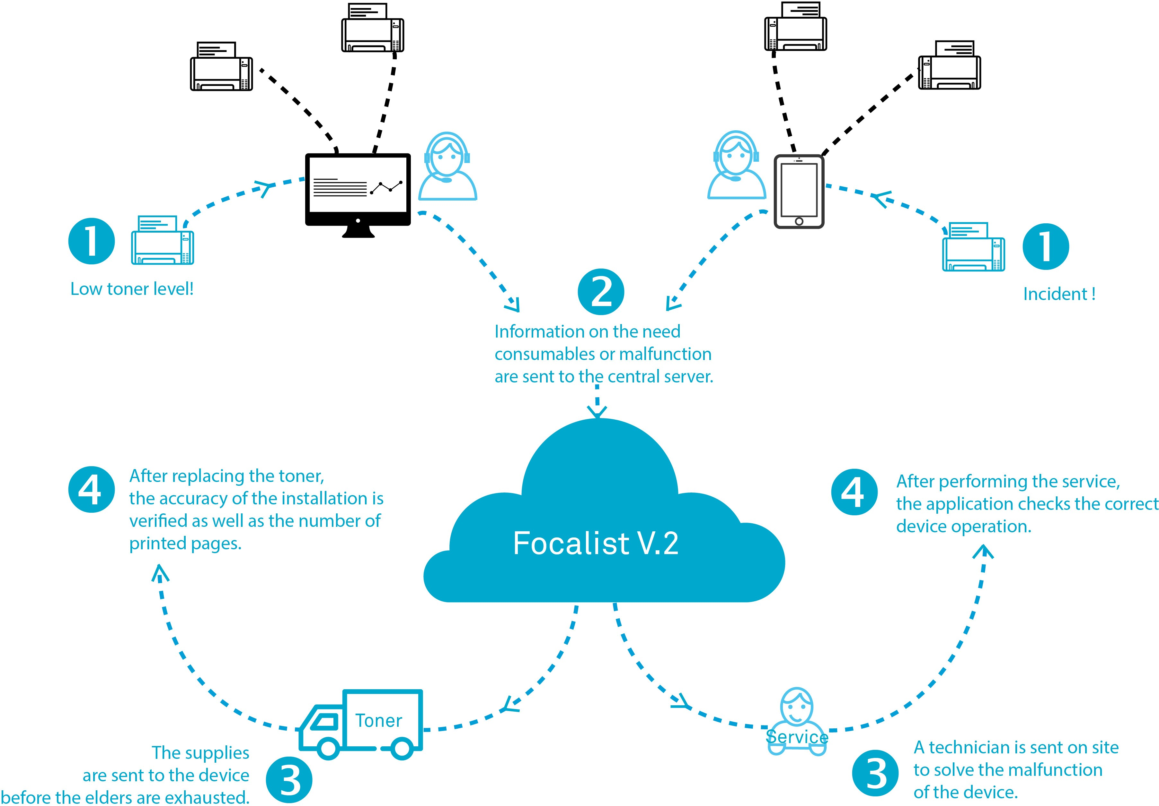

## Type of data collected from devices

Focalist® from devices gets the following data: The IP address (or hostname) of the device, Manufacturer and model of the device,

The serial number of the device, MAC address of the device, Device status,

Device counters,

Information about errors occurring on the device, Toner and drum levels,

Levels of maintenance kits, Levels of other supplies,

Serial numbers of toners and drums.



Focalist does not download from the devices any information concerning the printed documents. What is downloaded are only the total numbers from the counters, without information concerning the title and content of the docu- ment, or the person ordering the printing.

# TECHNICAL PRESENTATION

## Focalist® architecture

**Focalist® Cloud** - App server hosted by the Microsoft Azure service.

**Focalist® Monitor** - Thin client installed in the client’s network. The client is ins- talled on one of the network’s computers. The app aims at searching for printing devices and verifying their condition in a cyclical manner.

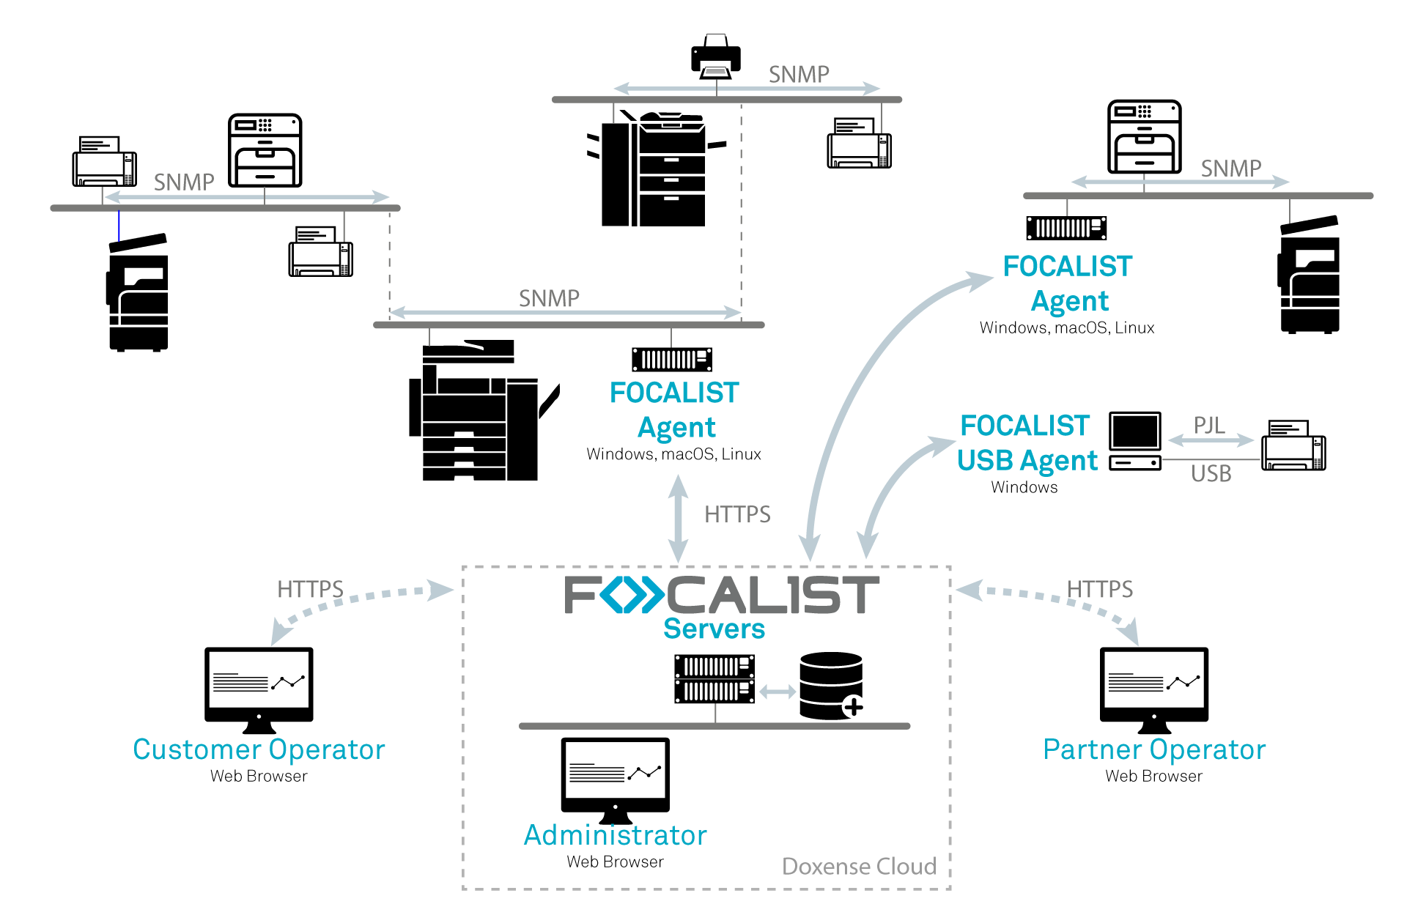**Focalist Web Site** - A console for managing devices available via the search engine under the address https://<partner_name>.eu-focalist.cloud

## Ports used in the internal network

The device polling schedule is configured by the end client via the app’s www interface. During an inspection of devices, the Focalist® client app takes advantage of the following protocols:

*Between the monitoring agent and the devices:*

* SNMP (port 161 (read only)); SNMP versions 1, 2 and 3 are supported;
* NPAP/TIPSI (port 9300) for some Lexmark devices,
* HTTP (80) and/or HTTPS (443) if the device’s embedded web server (EWS) or Web services are being used

*Between the application server and monitoring agents:*

* HTTP (80) during agent installation; not used after installation
* HTTPS (443) for data collection requests and responses

The method of reading a given printer’s model is implemented in the strategy selected individually for each printer model.

From the server the Agent receives information concerning the address of the device and a list of parameters which have to be read from a given address. The downloaded data is transferred to the server where it is interpreted and processed.

## Characteristic of connection between Focalist® Agent and Doxense® Cloud

When installing the Agent, its ID key is entered (generated by the server). During the ins- tallation, the Agent connects to the server and a unique identifier is generated for it. During following launches of the Agent it sends the received identifier to a server which verifies data and accepts (or rejects) the connection.

The Agent-Server transmission takes place with the use of an HTTPS protocol where data is encrypted with the SSL/TSL protocol.

## Information queries by the monitoring agent

The server maintains a list of data element addresses as OID (Object IDentifier) which are relevant for each device model. These OID are pointing to data structures known as MIB (Management Information Base) which organize the information made available for management in a tree structure where the branches have a meaningful name like a street name and a number, so the full path can be described as a succession of names or numbers separated by dots, and where each ending leave contains the information. There are multiple MIB’s; the public MIB’s are described by the ISO/IEEE standards in RFC’s. Additional information specific to each model can be made available by the manufacturers in their private MIB’s in a similar manner:

When a new printing device is discovered, a set of 40 to 60 OID’s are inspected to collect details on the device pedigree, counters, supplies and current alerts. The conversation between the agent and the device is held using SNMP frames:

If the conversation is broken by timeouts, the agent may retry to reconnect to the device.

Then the information collected by the agent is sent upstream to the server for processing, storage into the database and display on the web site and reports.

The information is then updated on a regular basis using the following cycles:

### Discovery Cycle

This cycle will browse the network to discover any new printing device that could have been added to the network since the last cycle. Address ranges can be provided using different formats or can be uploaded to automatically link the device address to a site.

Different cycles can be scheduled for different parts of the network and can be disabled. The schedules can be set on specific days of the week and specific hours.

Devices other than printing devices are just skipped and ignored.

### Meter and Supply Cycle

This cycle collects the device counters and supplies information including levels and can detect newly installed supplies. It can be scheduled up to every hour and down to a specific hour of a specific day.

For USB devices, the schedule by default is every 30 minutes, but it can also be aligned on the same schedule set up for network devices.

### Alert Cycle

This third cycle will collect pending alerts from the device with details on the severity level and the skill level required to fix the problem. This cycle can be scheduled up to each hour. Alerts will be displayed to the device history and maintenance alerts will be routed to the Maintenance dashboard for analysis and creation of a workorder if relevant.