

**Partner Administration Manual**

**7.25.0**

□<>XENSE

47, avenue de Flandre - 59290 Wasquehal- FRANCE - [www.doxense.com](http://www.doxense.com/)

**Table of contents**

Introduction 6

About Focalist 6

Components 6

First steps 7

Register and log in 7

Registration 7

Login 8

Add Company 9

Company Data 9

Locations 9

Prices 10

Summary 10

Installation of Agent 11

Installation on Windows 12

Installation on Linux 13

Adding printers 13

Summary 14

Dashboard 16

Devices 16

Companies 17

Supplies 17

Companies 18

Company 19

Statistics 19

Locations 20

Action 21

Prices 22

Use a simple billing method 22

The custom price for the device model 23

The custom price for the overall number of printed 24

Billing per toner 26

Coordinator 26

Notifications 27

Agent 28

What is an Agent? Why do I need to install it? 29

Agent Settings 30

Adding new agent 30

Order configuration 31

Check if the toner has been properly installed 31

After sending a notification, mark orders for supplies as sent 31

After sending a notification, mark orders for parts as sent 31

Block order for a toner, if its efficiency is lower than (%) 31

Order generation method 31

Ignored devices 34

Invoices 34

Other settings 35

Company data 35

Additional settings 36

Dictionaries 36

Devices 37

Device 37

General information 37

Alerts 38

Orders 38

Supplies 39

Statistics 39

How does the Focalist count pages? 39

History 39

Map 40

Device settings 40

Maintenance 40

SNMP settings 41

Remote panel 41

Supplies management 42

What is supply management in Focalist: 42

What is toner fulfillment process: 42

Adding supply (first supply installation) 43

Inspection of supply status: 44

Supply replacement 44

Adding order automatically 44

Alerts 44

Alert list: 45

Waiting orders 45

All orders 46

All supplies 46

Maintenance 47

Active errors 47

Repaired 47

Maintenance request 48

Reset password 48

Reports 49

Predefined reports 49

List of your reports 49

Create your own report 50

Report schedule 50

Settings 52

Account 52

License 52

Users 52

Profiles 52

Appearance 53

Supplies model numbers 53

System options 53

Notification 53

Order configuration 53

Couriers 54

Supplies manufactures 54

Currencies 54

Troubleshooting- Hewlett Packard devices - Invalid Certificate 55

Context 55

Cause 55

Resolution 55

**Copyrights**

© 2024. Doxense®. All rights reserved.

Focalist and all product names or trademarks mentioned in this document are trademarks of their respective owners.

Reproduction in whole or part, by any means whatsoever is prohibited without prior author-

isation. Any electronic copies, either by photocopy, photograph, film or any other means is an offense.

|  |  |
| --- | --- |
| 47, avenue de Flandre 59290 Wasquehal - FRANCE  [contact@doxense.com](mailto:contact@doxense.fr) | Tel : +33(0)3.62.21.14.00  Fax : +33(0)3.62.21.14.01  [www.doxense.com](http://www.doxense.com/) |

# Introduction

## About Focalist

Focalist is a modern solution to manage a fleet of printing devices on multiple networks, using public or private cloud-based servers and a set of data collection agents on the end customer network. From a web browser, customers can display the status of devices and their supplies, and they are enabled to automatically order supplies and routing of device alerts to qualified maintenance teams.

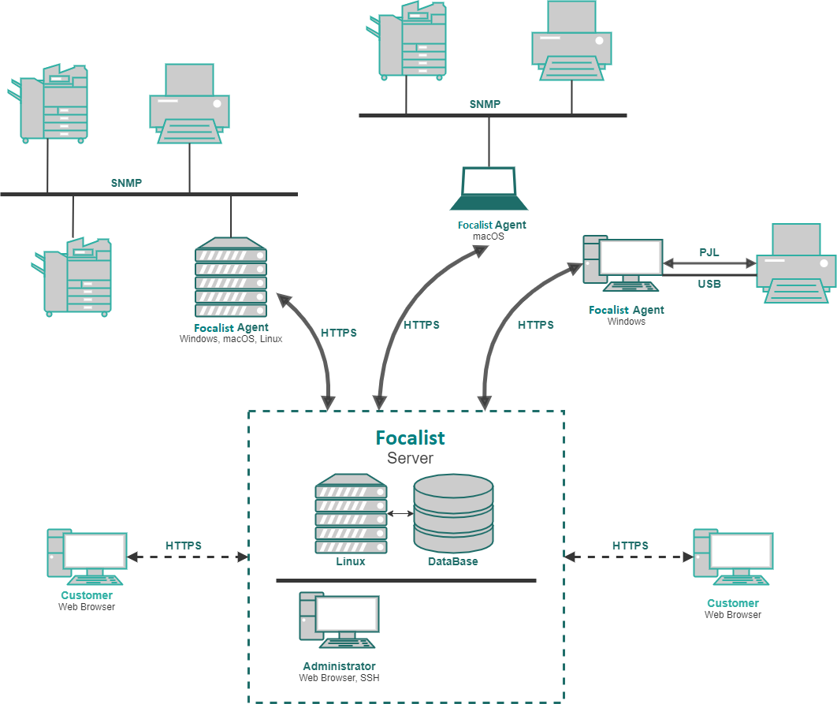

### Components

* Starting from the end user, there is a Web Browser client that allows Customers to manage their fleets of printers.
* Afterwards there is Server infrastructure that can be provided directly from Focalist

or can be installed on Customer devices, and be managed locally. The server part includes: database and web components that allow the app to work.

* Agent is installed locally in each network where customer printing devices are con-

nected. It searches the network looking for printing devices, and after adding them to the company device list it monitors their state as well as their supplies level.

# First steps

## Register and log in

In order to get access to the application, it is necessary to complete the registration form. Registration looks and works similar regardless of versions, based on the public Focalist server and local one installed on client side infrastructure. The difference is access to the app after login. Public version has a default 14 days free trial. On the other hand, servers installed on customer devices require a bought license, to get access to features after login.

### Registration

1. Registration according to server you are going to use is available on:
   1. In case of pubic Focalist server: <https://eu-focalist.cloud/public/register>
   2. In case of local Focalist server, in depends on configuration but Server- IPAddress/v3/public/register
2. In the drop-down list which is located in the upper right corner, select the interface

language.

1. Fill the following fields with your personal information:
2. Email(login) - login of the administrator who manages the application. An email confirming correct partner registration will be sent to the email provided.
3. CHOOSEPASSWORD - administrator password to app , be sure it’s safe.
4. Phone - contact information.
5. Country- region information.
6. Subdomian - defines the address under which the platform will be available. ([https://<YourSubdomianName>.focalist.cloud/](https://yoursubdomianname.princity.cloud/))
7. Click on Register in Focalist

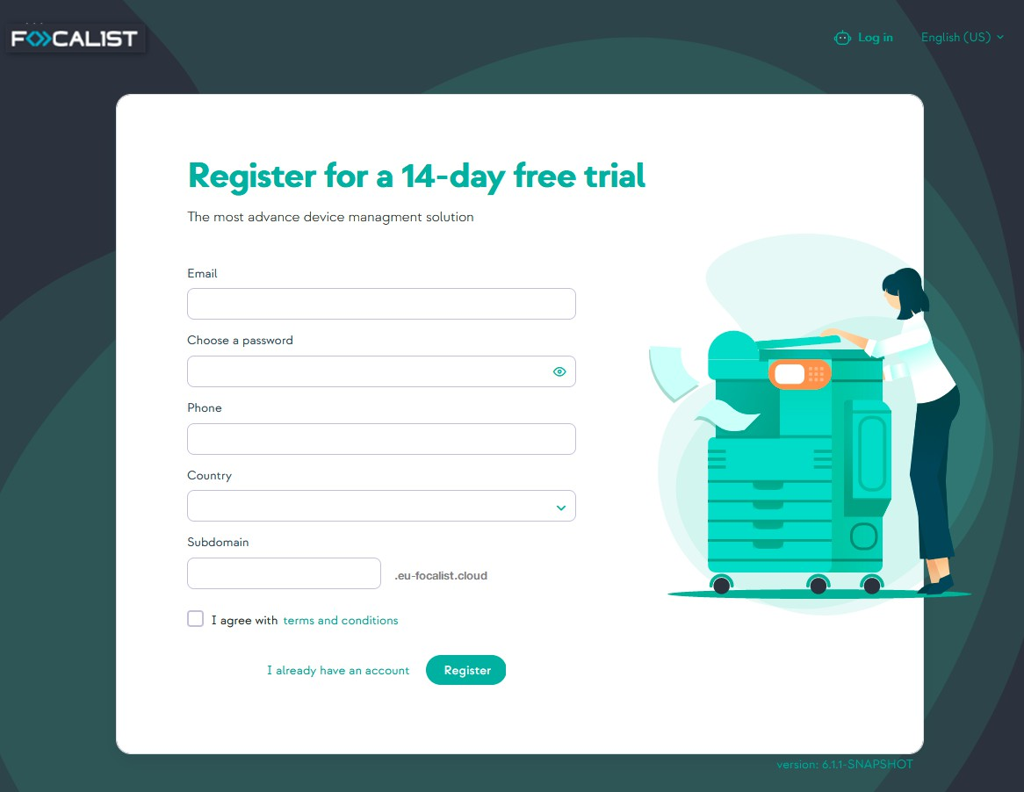

### Login

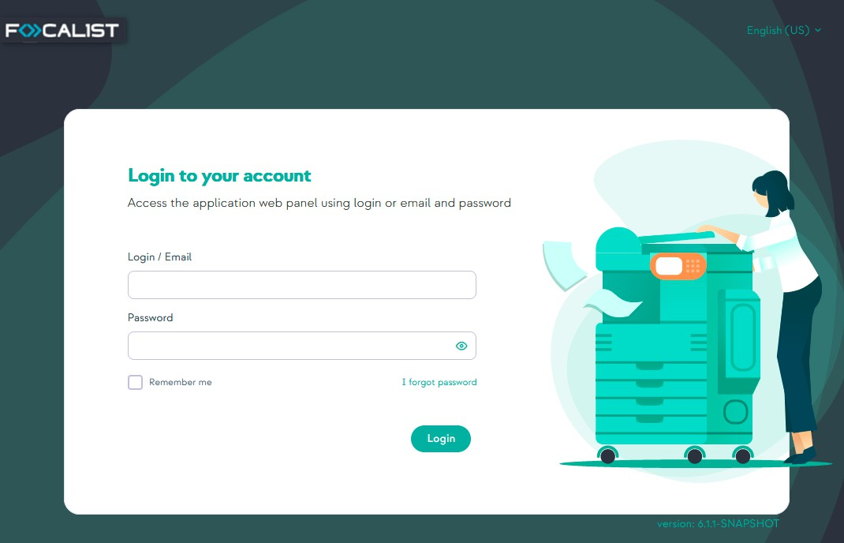To login you enter [https://<YourSubdomianName>.Focalist.cloud/](https://yoursubdomianname.princity.cloud/) then write your login (email) and password after which click on Login button for further configuration.

If you are using a public Focalist Server you can start working now, but in the case of a local one you need to contact support to get your license first.

## Add Company

In the Focalist application, devices will be assigned to companies and their branches. That' s why after login to the application a new user’s first step should be adding a new company. After login, your home page should be "Companies", click the green button with text "Add a new company".

### Company Data

After clicking the button “Add a new company”, you access a form in which you enter the company data. The entered data can be edited later from the settings of individual com- panies. Required information about the company is Company name, Language, Country, Address, Postal code, City and Prefix. Optional fields are Tax ID, Trade.

Prefix: short name allowing easy identification of a given company. All devices in the com- pany will receive IDs consisting of: {Prefix}-nextNumber of Device. For example, if the Com- pany name is "DEMO", identifiers of subsequent devices are DEMO-1, DEMO-2; etc.; Marking printers allows for the quick and convenient linking of devices to the company in which they are located.

Company contacts data: are information about company employees responsible for the maintenance of printing devices. Messages from the system will be sent to this person (e.g., about the dispatch of consumables or on detected device failures). The supervisor provided at this stage will be marked by the system as the ' company' s main coordinator'.

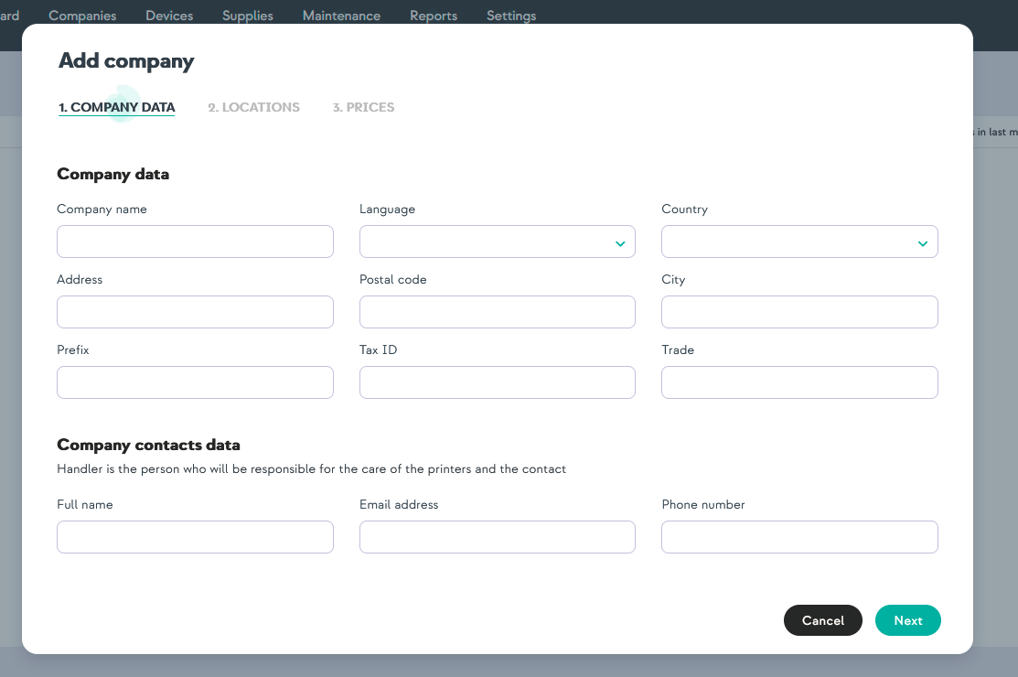

### Locations

At the Locations step you can add more locations for your company, and you can always edit them or add more in the company settings. Multiple locations can be useful during

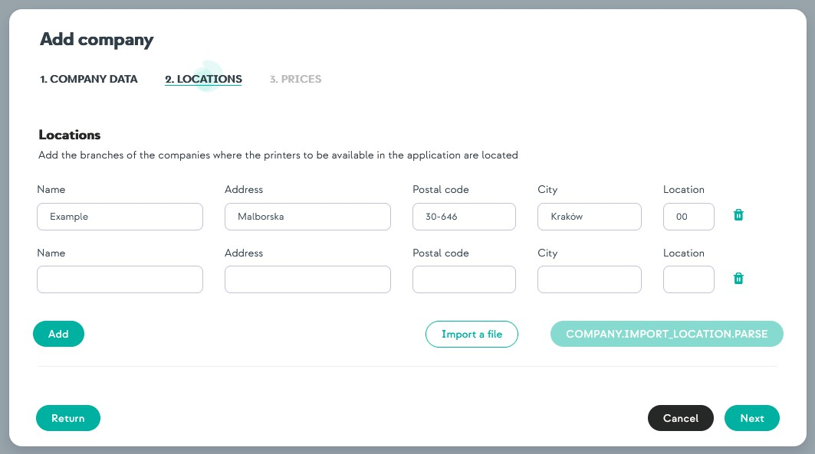adding multiple printers located in different places. Thanks to that option, you can define where your printers are located.

### Prices

In the Prices tab, select the company’s settlement model. To do that you choose either set- tlement per printed page or settlement per toner. Next select Currency from default one or add another. You can always change that in company settings.

Settlement per printed page

Enter here standard prices for a page divided by mono, color and scan. More advanced options such as the number of pages in the subscription or subscription fee can be cus- tomized later

Settlement per toner

Prices for individual toner models can be changed in the company options.

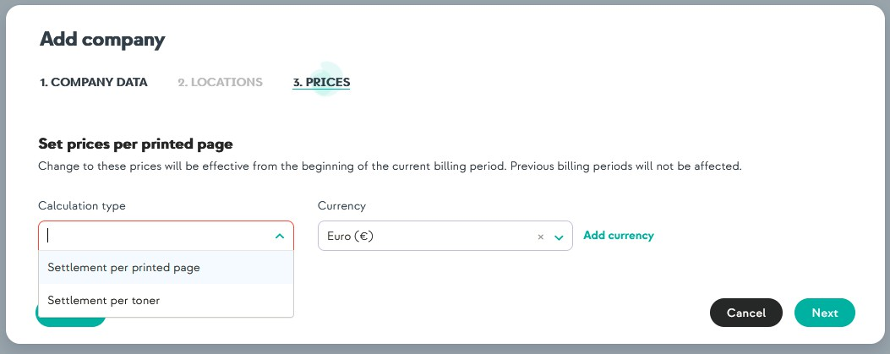

### Summary

After completing the data entering, there will be a summary of the added company inform- ation.

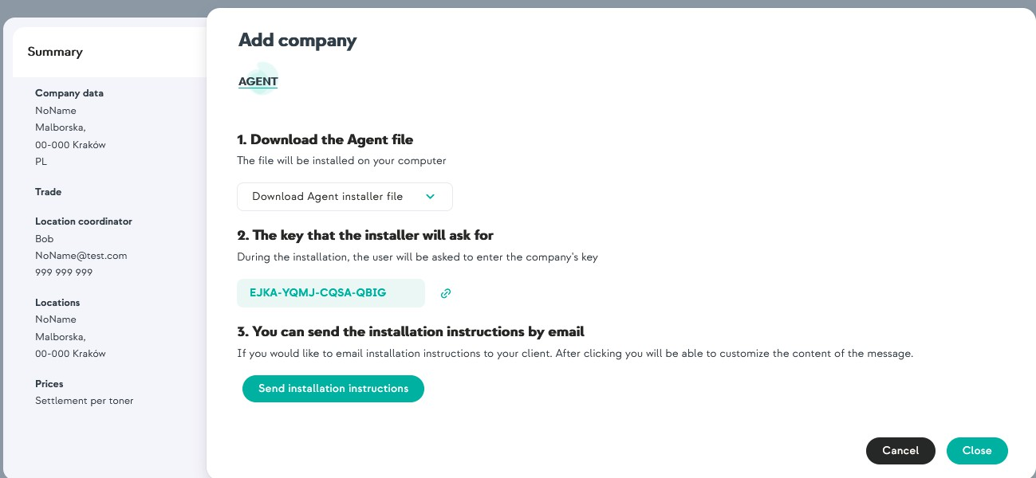

You can just close this window and go to the next step or download the Agent files now. To do that you need to select from the drop-down list the version for your device. You can also additionally send instructions with links to download the Agents to mail.

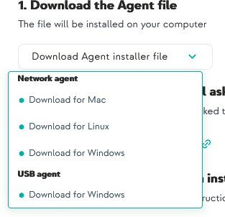

## Installation of Agent

When the company is added , the next phase would be installation of Agent. As you can see at About Focalist, Agent is an important part of infrastructure. It is responsible for searching for other devices in the network, checking their status and sending information about them to the server.

If you didn' t download agent, you can find it at:

Companies -> Selected company(click on company name)-> Agent -> Download Agent installer file

Before you start installation you need to have an Agent key. You can get it from the sum- mary window after adding company or find it at Agent settings. To get there you have to go to:

Companies -> Selected company(click on company name)-> Agent -> click on 3 dots in

the column action and select edit:

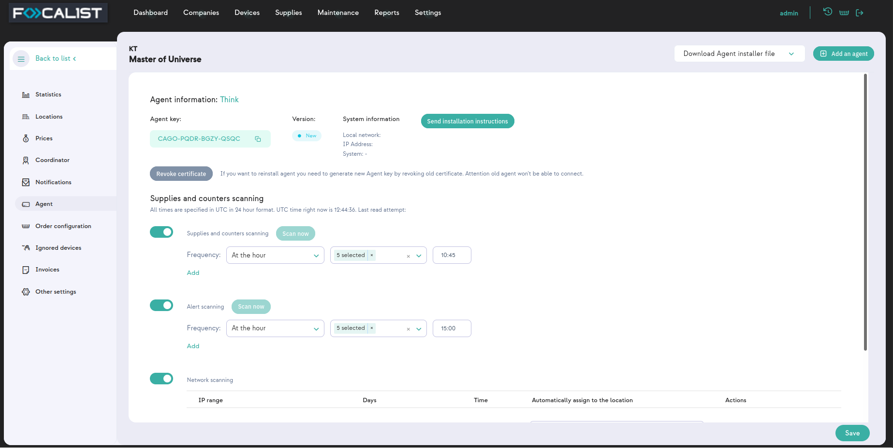

Under the company name you can find Agent Key for selected Agent. You will need it dur- ing installation.

Devices that will be used for installation need to be a part of the network where printing devices are connected. If you have printers in multiple networks you will have to install an Agent for each one.

Also for installation independently from the operating system you need to have installed JDK 8+ or JRE 8+ on your device.

### Installation on Windows

For installing Focalist Agent on Windows you need to run downloaded instalator “Focalist- agent.msi” and enter the mentioned earlier Agent key.

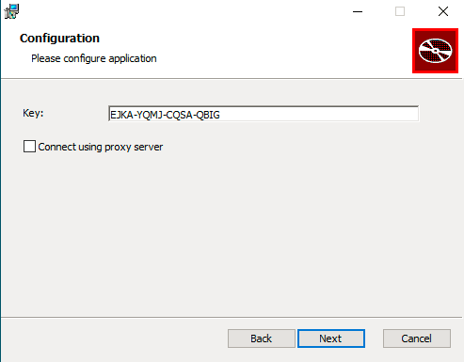

### Installation on Linux

1. After downloading, unzip file (preferred to directory /opt/Focalist-agent).
2. Open the terminal and go to the agent destination directory.
3. Run script install_linux.sh as root.
4. Enter your Agent Key and press enter.

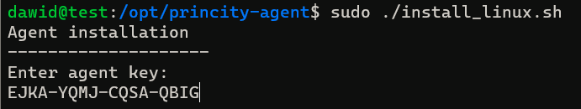

If everything went as it should be in agent settings status should change to connected.

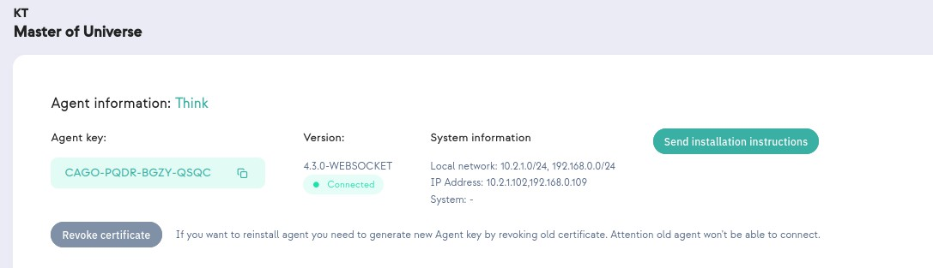

## Adding printers

Focalist is an application to manage a fleet of printers, so final steps that would allow using an app main feature is adding printers. To do that you need to make sure that installed

agents are in the same network as printers and they are connected to the server.

1. Select Devices from the menu at the top.
2. Press button Add a device.
3. 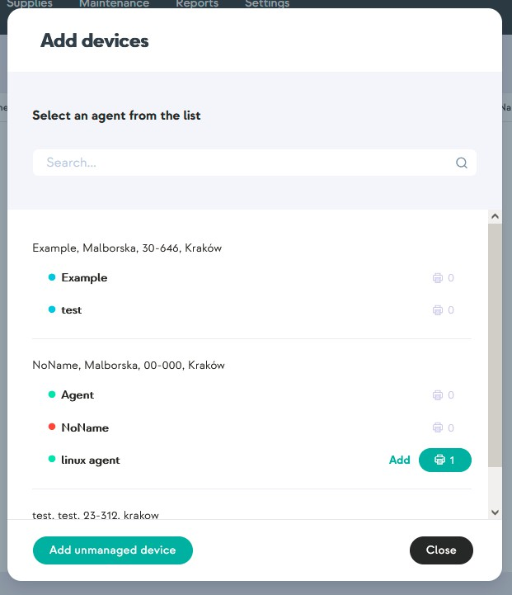You will see a list of companies and agents in them, you need to choose an agent with new device status, at the screen below it is a one named “linux agent”.
4. Before adding a device you may choose location from the list of locations added for the company(You can always change this latter in print settings).
5. Finally check the mark near the print name and press Save assigned devices.

## Summary

From this point most of the application features are available. You now have remote access to things such as:

* + Collective statistics of the state of supplies for added printers and the ability to send

prior notifications in the event of a lack of any resource.

* + Generating reports.
  + Remote access to device control panel.

They will be defined in detail in the description of the individual modules.

# Dashboard

The dashboard contains some statistical information. By default it will load data from one company, the first one on the list. However, you can load more or change companies in the right menu.

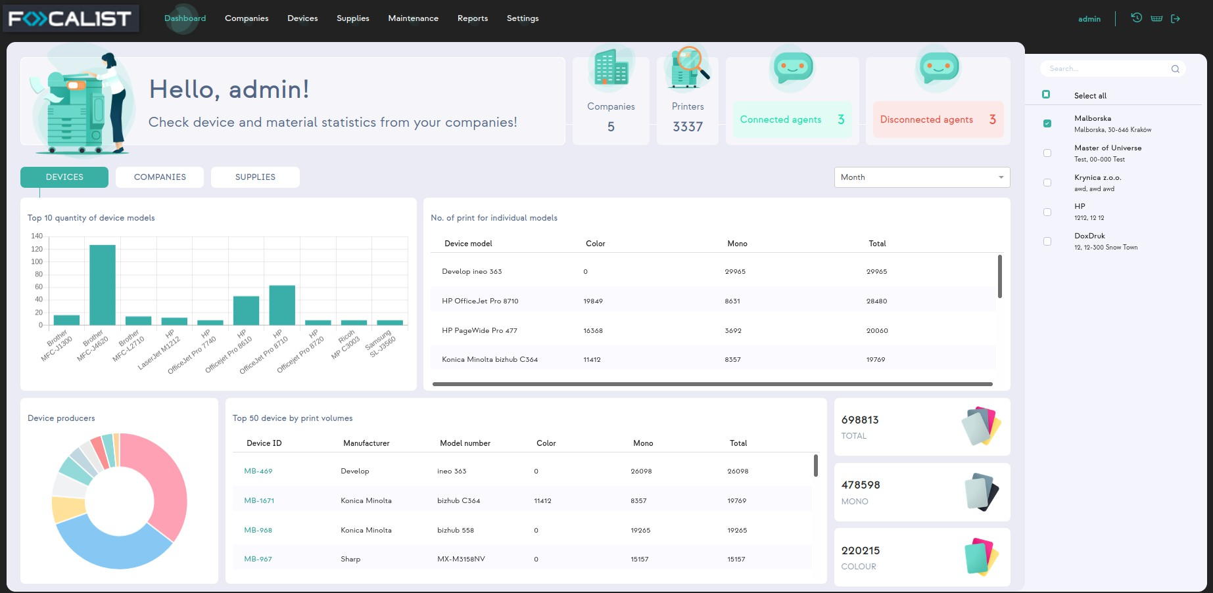

The first line at the top of the Dashboard view contains information about the entire applic- ation, that is the total number of: companies, printers, connected agent and disconnected one. On the other hand, in the part below there is statistics informationes only for chosen Companies (by default only one). This informationes separate into three different parts:

## Devices

This is the basic look that is seen on entering this tab, the one that is on the screen above. You can see here some statistics for your top devices used in chosen companies.

## Companies

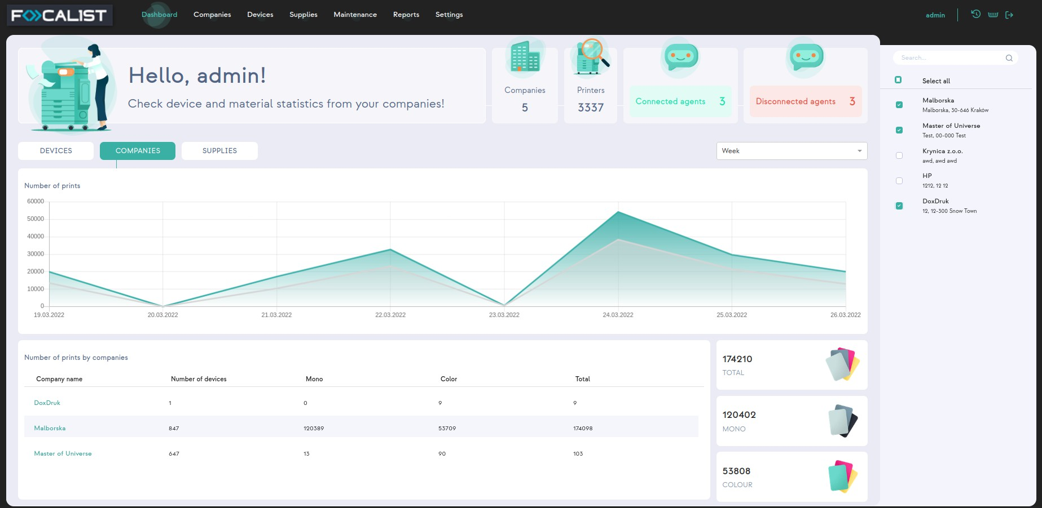

In the Companies section there is a chart showing the number of pages printed in a selec- ted time interval. In the chart, the total number of printed pages is marked in colorful lines, while Mono is shown in gray lines.

### Supplies

This preview contains all information from tab Supplies. Thanks to the menu on the right site all of that data can be easily sorted by the chosen company. This allows to display in a transparent form information, enabling a quick preview of the emerging shortages of resources.

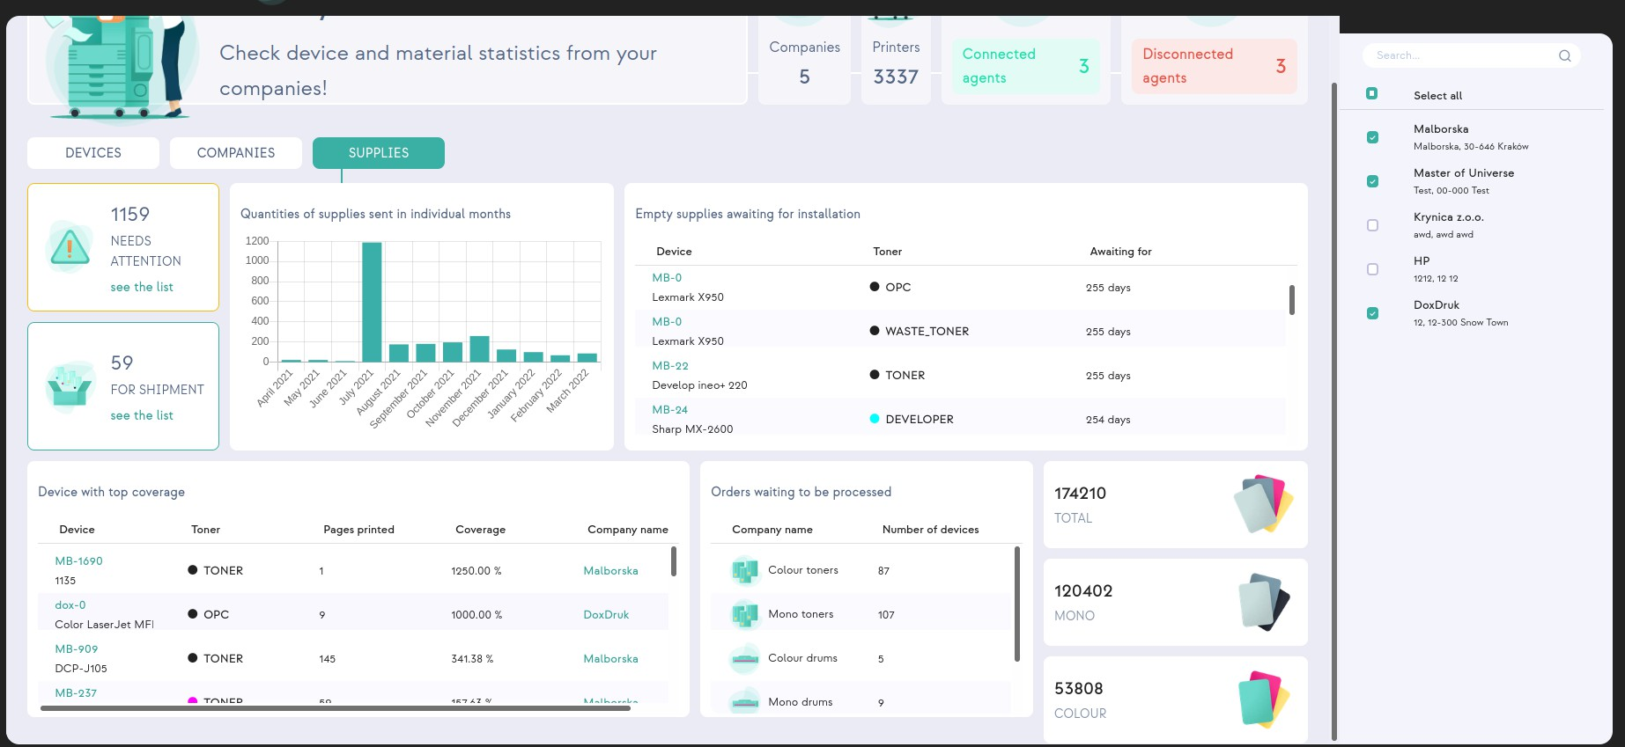

# Companies

Tab Companies contains the list of companies, with basic information about their current state.

Displayed information according to columns are as follows:

* Company name, as column says, this is company name together with the main loc- ation below it (by choosing company name you can go to selected company set- tings)
* Prefix, shortcut representing a given company
* Locations, number of added location for certain company(by clicking on them you will go to company location settings)
* Billing type, represents method of settlement with each company
* Agent, last used agent with date and current state
* Number of devices, represent information about amount of devices attached to a company(by pressing it you will go to device tab with filter on for the chosen com- pany)
* Volumes in last month, number of prints from previous month
* Action, by clicking 3 dots you can choose edit and go to company settings, or deac- tivate company.

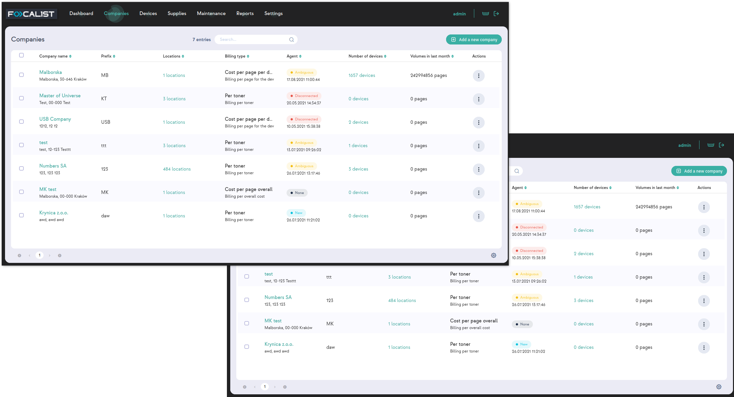

The search is based on data in columns: Company name and prefix.

“Add a new company” button and how it works has been described in the first steps in the subsection Add Company

In the lower right corner there is a gear icon where you can change the default display information about each company. Such as visible columns and rows count.

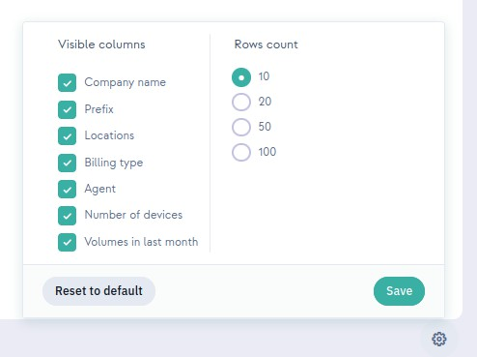

## Company

Company is a module generated for each company, which can be specified as company settings. You can go there by pressing on company name or choosing edit from possible actions on companies list in Companies tab. In this module, you can modify the settings for the selected company. The settings are splitted into individual elements depending on their subject and functionality. Each of them will be discussed in detail.

### Statistics

Statistics is the first tab in company settings, it contains basic information about company and statistics of made prints in the company.

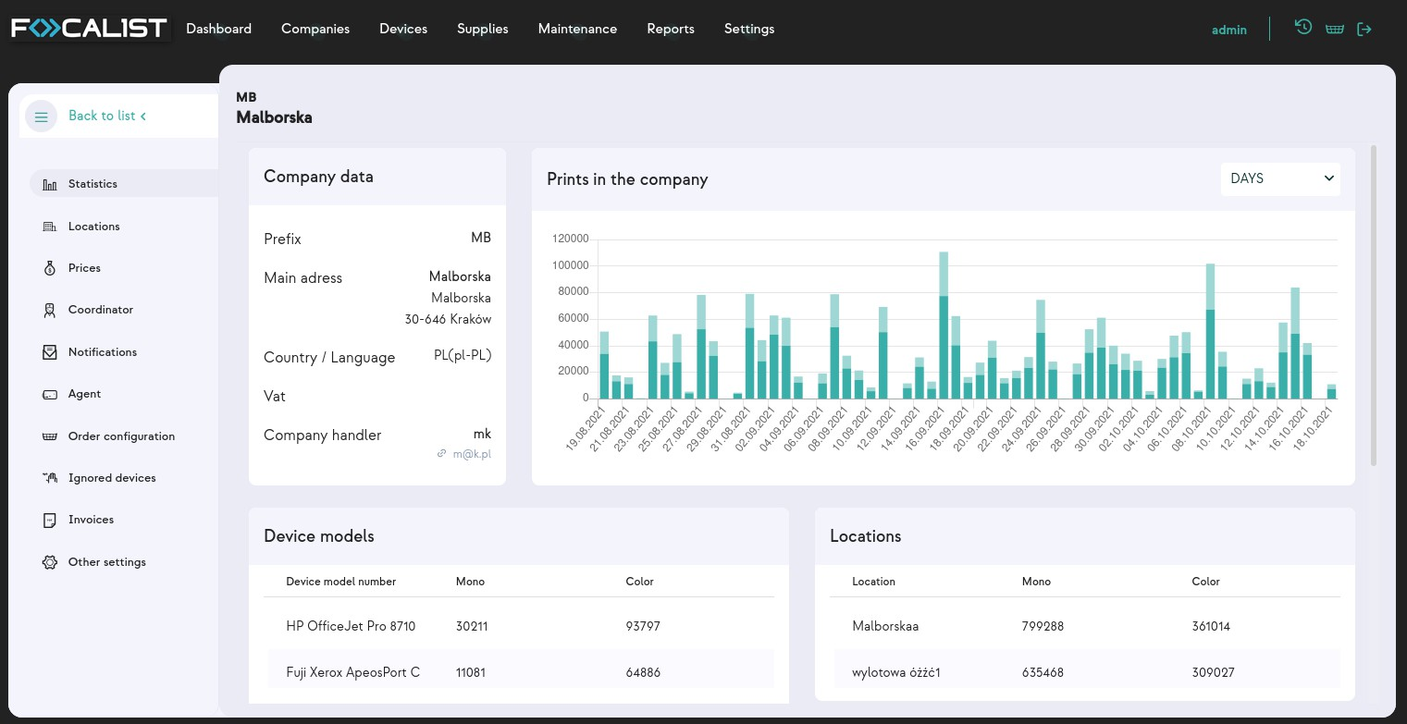

Statistics were divided into four labels:

* Company data, information about Company
* Prints in the company, visual representation of pages used, which can be displayed by days or months
* Device model, list of devices as well as printed pages(mono and color) for each

device

* Locations, list of all locations added to the company, together with printed pages (mono and color) in each

### Locations

This tab contains information about the locations of printers within a given company. Each location in the table by default contains information about:

* Location name, given name to location
* Address, accurate address with street name, number, postal code and city
* Coordinator, a person assigned to be responsible to perform maintenance activities in the location
* Number of devices, devices in the location
* Active (Active or Deactive)
* Action (Statistic, Edit, Activate/Deactivate, Delete)

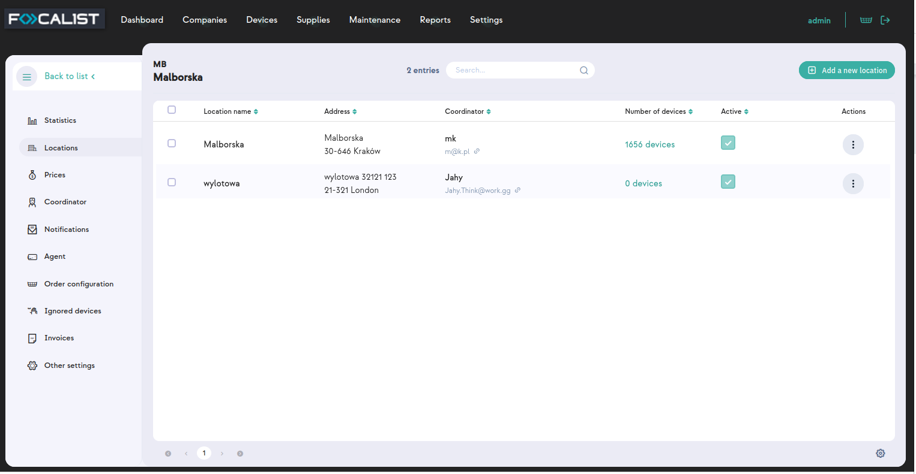

#### Action

Statistic, display statistical information about printed pages, per month or day in a given location.

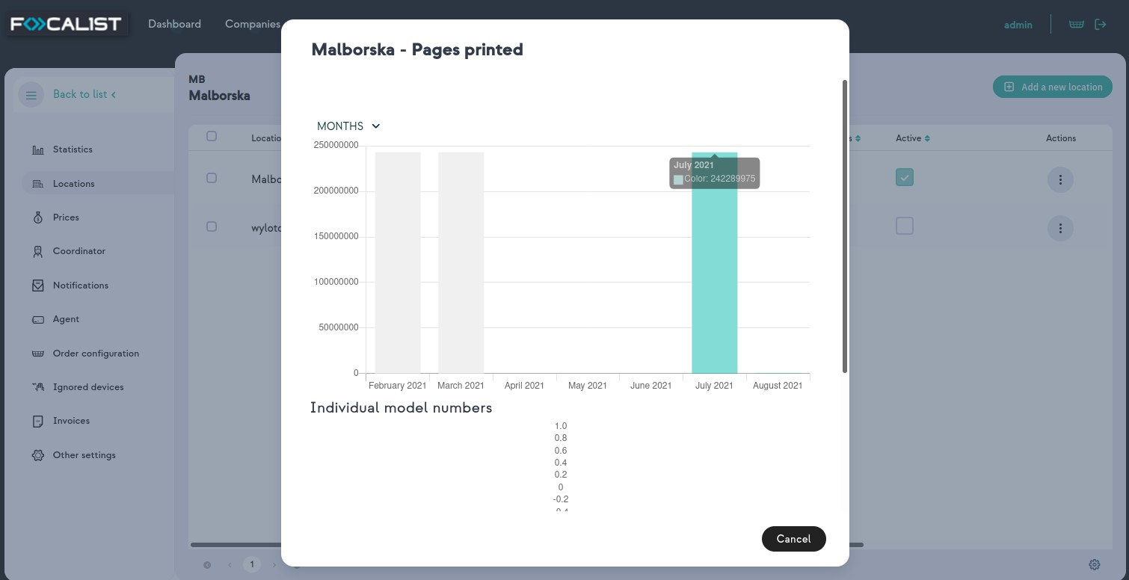

Edit, allow you to modify/update location details, such as address and coordinator. You can choose a coordinator from the list or create a new one which would be added to the database after saving.

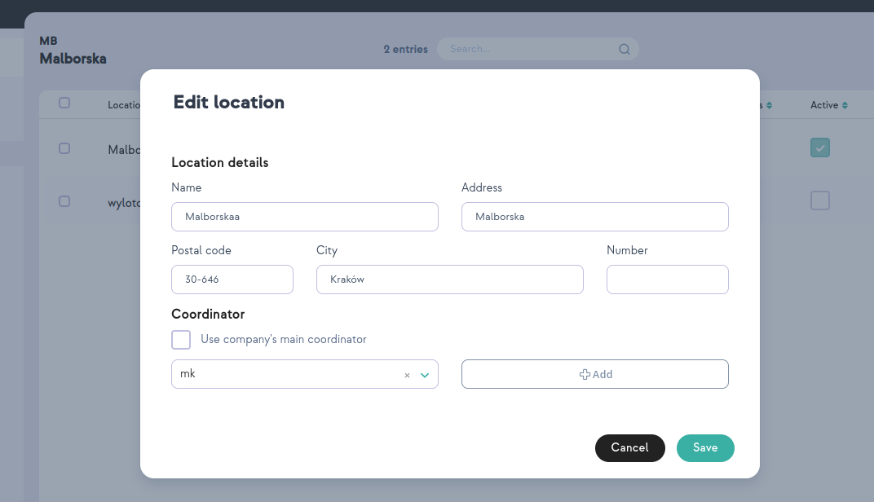

Activate/Deactivate, you can activate or inactivate selected locations. If location is active then it can be chosen during adding a new device, if it is set to inactive at that point it is not displayed there.

Delete, it is used to delete permanently selected branches from the locations in a given company.

### Prices

Prices is a modul where you can specify the billing type for the chosen company. You can choose your billing type by clicking on the “Advanced settings” and selecting one from the drop-down list. User can' t create or change the settlement model, he only has the option to modify the selected model.

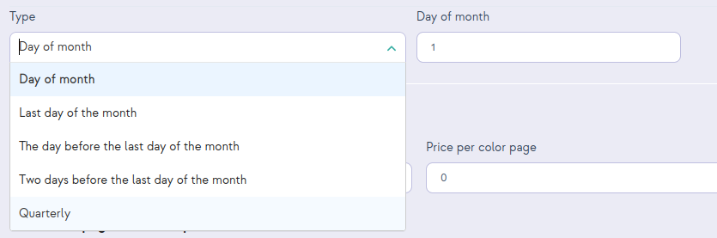There are four different billing types, but each of them has one common option on top to choose. It' s "Type". This option is responsible for defining the range of data responsible for billing reports .

#### Use a simple billing method

In the default settings of the company, the application uses a simple billing model, visible in the ' Prices' tab, which takes into account the prices quoted during the company regis- tration for the monochrome, color, and scan. The user can change prices at any time dur- ing the company' s operation.

Note: it should be remembered that a change in these prices will apply from the beginning of the current accounting period. Previous billing periods will not be changed.

In addition, the user can define the number of pages available in the subscription for the device. This is an additional option (subscription system), which allows the client to determ- ine what number of printed pages is settled in the general terms of the contract, and each page above the set threshold will be paid in accordance with the prices specified in the first section.

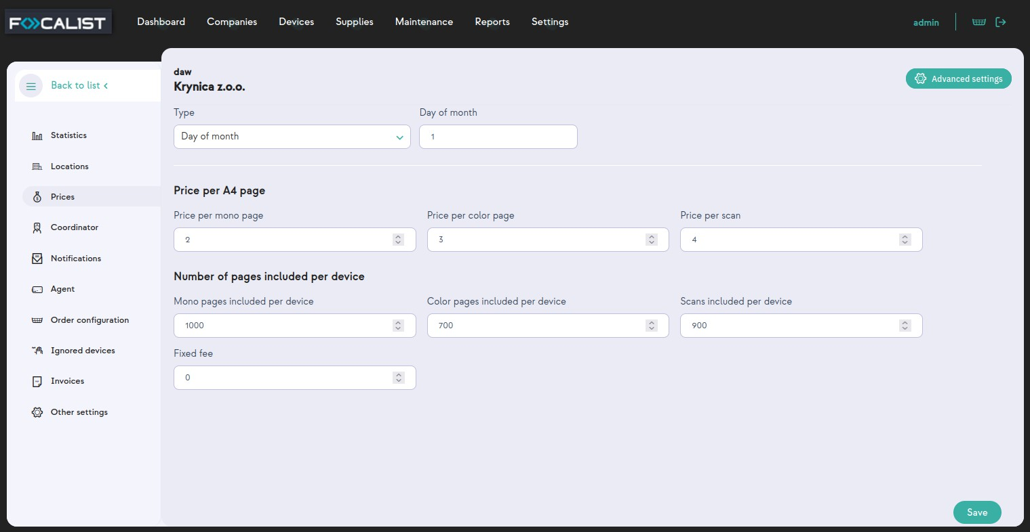

Be sure to click ' Save', as without this, changes will not be entered into the system. This applies to all billing types.

#### The custom price for the device model

Custom price for device model allows to set unique prices for a defined printer. In this model there are default set price thresholds as in previous one, but additionally we can define rates for a specific printer model or an actual connected printer.

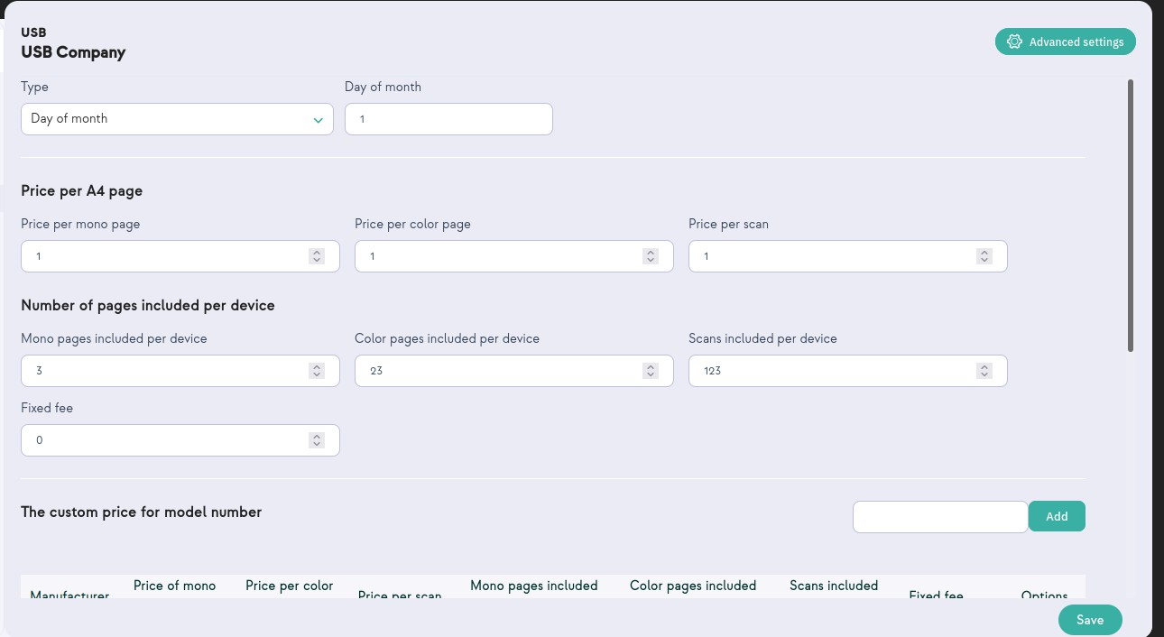

By clicking on the '"Add" button window with "Manufacturer" and "Model number" lists will appear. You need to choose an option in each list and press save.

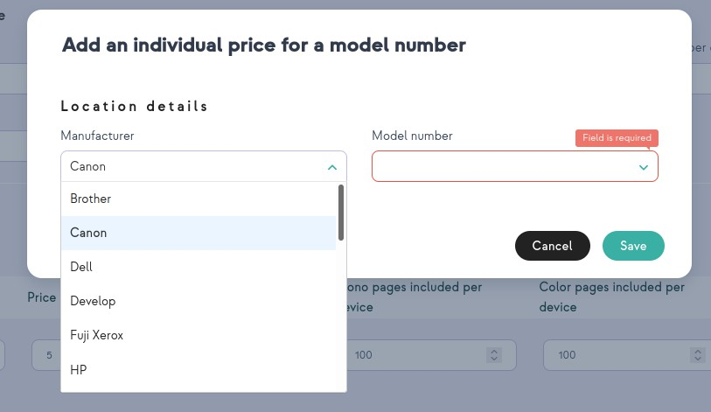

The administrator can define individual prices for several device models at the same time:

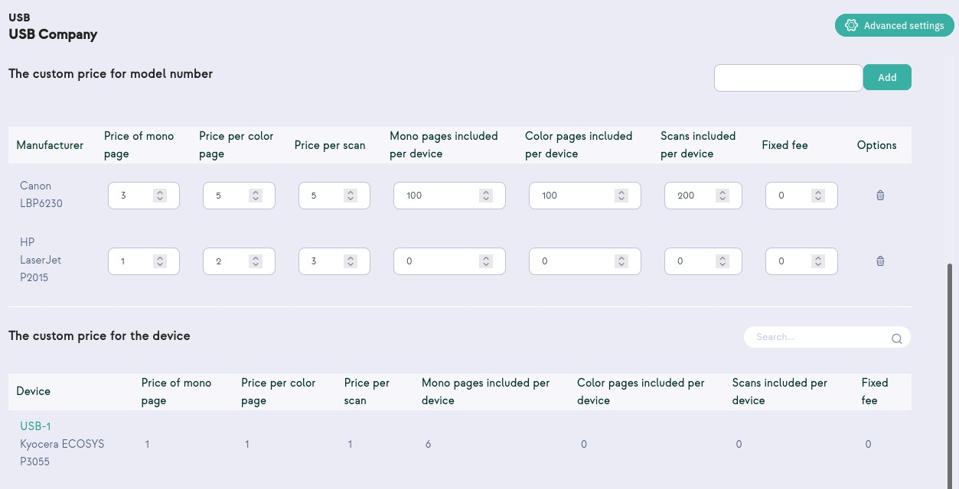

#### The custom price for the overall number of printed

Model is based on multiple thresholds. This option allows you to set the price for printouts in specific quantitative thresholds, which are set individually by the customer. The system calculates the settlement of the contract according to the given prices, that is depending on the number of pages printed.

After exceeding the number of printed pages given in the first threshold, the system cal- culates the price for the page given in the second threshold. The number of price thresholds is arbitrary and depends on the client' s needs

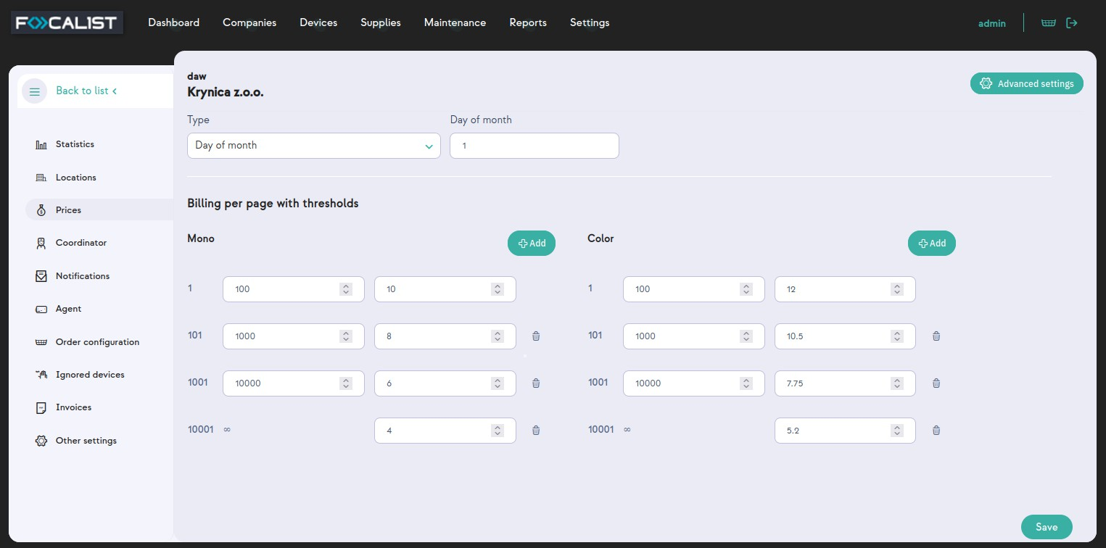

.

Note: It is necessary to use the ' Save' option when you have finished, otherwise the sys- tem will not remember the previously set price thresholds.

Example:

Customer printed 13,207 mono pages and 11,216 Monthly settlement will look like this:

MONO:

|  |  |  |  |  |
| --- | --- | --- | --- | --- |
| FROM | TO | QUANTITY | PRICE | FINAL PRICE |
| 1 | 100 | 100 | 10 | 1000 |
| 101 | 1000 | 900 | 8 | 7200 |
| 1001 | 10000 | 9000 | 6 | 54000 |
| 10001 | ∞ | 3207 | 4 | 12828 |
| SUM |  | | | 75028 |

Color:

|  |  |  |  |  |
| --- | --- | --- | --- | --- |
| FROM | TO | QUANTITY | PRICE | FINAL PRICE |
| 1 | 100 | 100 | 12 | 1200 |
| 101 | 1000 | 900 | 10,5 | 9450 |
| 1001 | 10000 | 9000 | 7,75 | 69750 |
| 10001 | ∞ | 1,216 | 5,20 | 6323,2 |
| SUM |  | | | 86723,2 |

Note: If the contract provides for the number of pages printed in a month for which you will not be charged, you should use the ' subscription system'.

#### Billing per toner

Initially, this model is empty. To use it, first of all, you need to add an agent and scan the net- work for a new device. After scanning the network you need to add a found device. Con- sumable parts will be detected and added there. If the agent did not find the device, you will not be able to set anything in this model. The application allows you to set a price for each consumable.

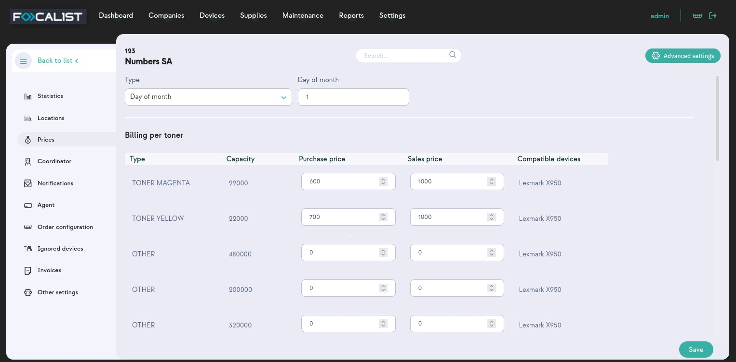

After entering them into the system it is necessary to use the ' Save' option, otherwise the system will not remember the changes.

Note: Sometimes it takes some time to load consumable parts. So if you are sure that you have already added devices, be patient and wait.

### Coordinator

In the Coordinator tab, there is a list of coordinators defined in the company’s con- figuration. As previously mentioned, Coordinators are persons responsible for device main- tenance in dedicated locations or the whole company. Each company has one main coordinator who can be chosen by default while adding new locations within the com- pany. The company' s main coordinator is marked on the list of all coordinators.

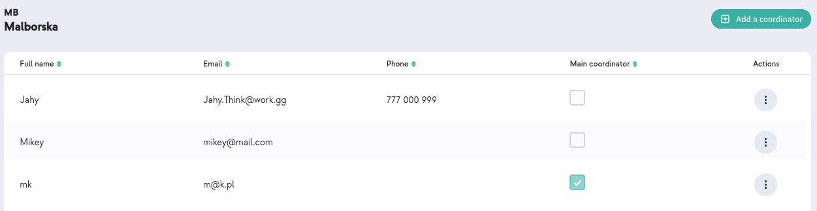

The administrator has the option to add a new coordinator using the ' Add coordinator' option.

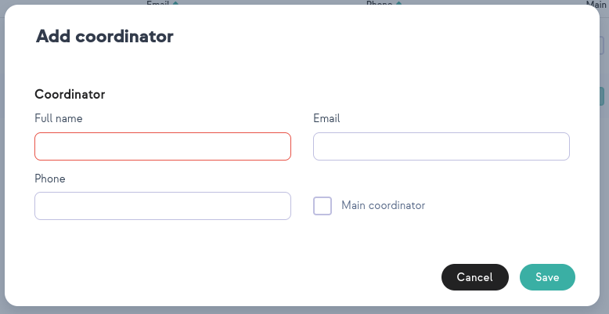

When you add a new coordinator, you can mark it as your company' s main coordinator or do it later if you need to. In the editing level, the same option is available to identify a person as the main company' s coordinator.

### Notifications

In the notification tab, the application user can manage the information delivered directly to the email.

On preview, notification have been separated into category as follow:

* Device notifications
* Supply notifications
* SNMP alert notification
* Agent notification
* Other notifications

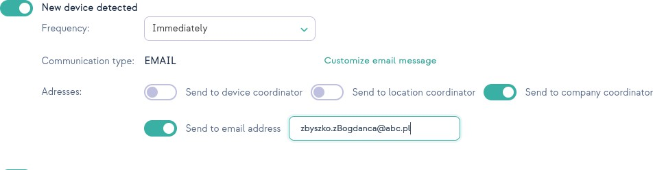

To enable chosen notification, you have to click on the ON/OFFbutton next to a given noti- fication. After that you can write a custom email or select recipients from the list.

Additionally you can choose the frequency of the email.

Customize email message

This feature allows you to customize email that would be sent. You can add additional information depending on preferences.

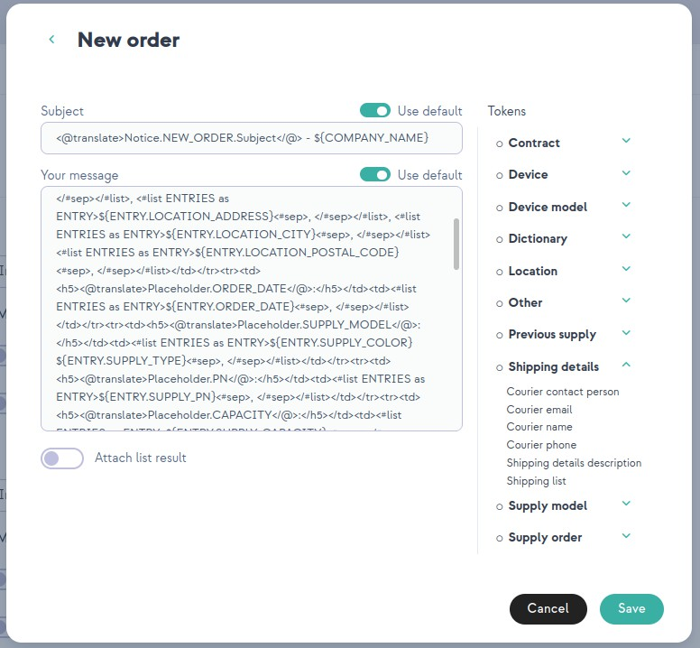

Note: Each company has separate settings, so your setting will apply only for the company that you are currently editing.

### Agent

Agent tab provides us with features to manage agents. After entering a tab you can see a table with agents in the company. There is displayed information such as agent name, cur- rent agent status, there are also actions which are edit/delete agents. In case that selected company has only one agent you will be automatically moved to that agent' s setting.

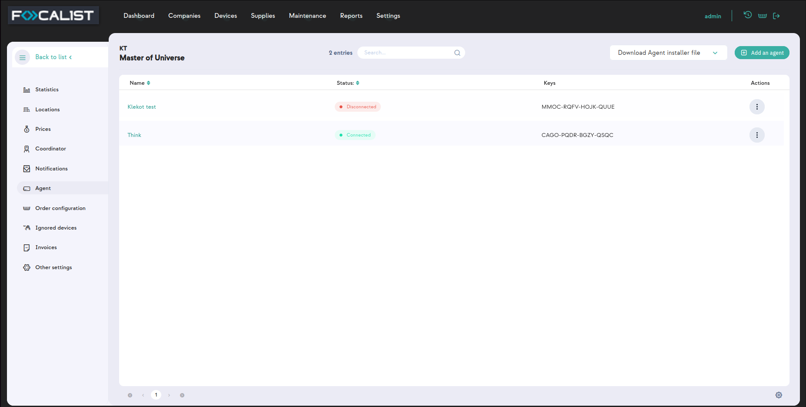

Status:

* New - added in server application but not connected to any agents on devices.
* Connected - properly working connection
* Ambiguous - multiple agents have different status
* Disconnected - can' t connect to agent

#### What is an Agent? Why do I need to install it?

* You can think of an agent as something like a proxy that allows our application to gain access to printers.
* Each network with printers needs an agent installed on one of the PC’s in the net-

work. We call them Network Agents, and each one needs to have a different logical agent in the Company->Agent tab.

* In the case of a usb printer You have to install a USB Agent. To work properly the

printer needs to be connected to Computer with a USB Agent.

* For one logical agent in Company->Agent tab you can have multiple USB Agent con- nected. You can connect One Network agent and multiple USB agents to one logical Agent.
* USB Agent is not available by default. To unlock it you have to contact support.
* Agents allow remote access to the printer panel but it' s not available by default. To unlock that you have to contact support.

#### Agent Settings

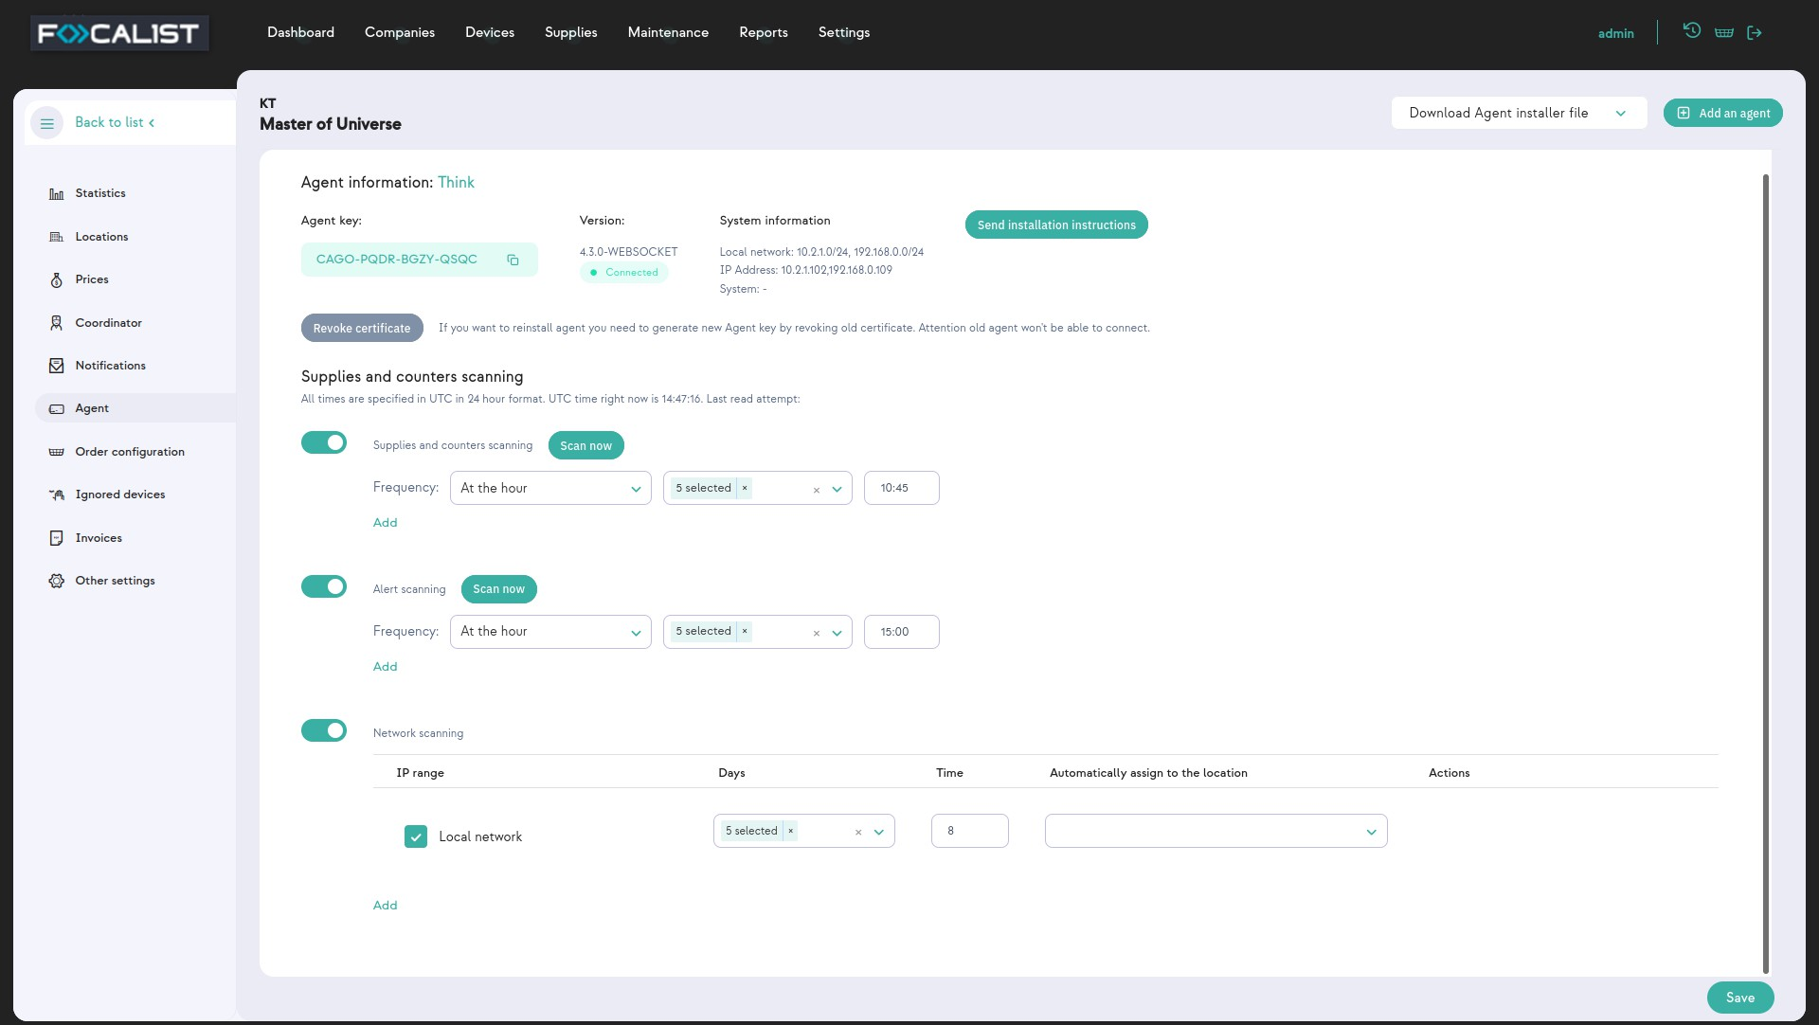

Agent Information

In this section there are basic information about selected agent, such as:

* Agent name - given name to agent we recommend giving names that can be easily identified with the device where the Agent is Installed.
* Agent key - used to connect Agents to the server, needed during Agent installation.
* Version - information of currently used agent version
* System information - IP address where network agent is installed.

Revoke Certificate

Each logical Agent in the server can have only one network Agent. If you want to reinstall an agent or install on a different device, you have to revoke the certificate from the old one. This button is responsible for it on the server side.

Supplies and counters scanning

In this part you can customize a scheduler for scanning which does Agent. Possible scan- ning option was separated into 3 different parts:

* Supplies and counters scanning
* Alert scanning
* Network scanning

Beside setting the scheduler, you can also use the option “Scan now” to check the current state of devices. Additionally, the scheduler also can be excluded by the ON/OFFbutton placen on the left from the scheduler name.

#### Adding new agent

To add a new agent you have to press the “add an agent” button which is in the top right corner and write a new agent name. Installation and adding process is described in Install- ation of Agent.

### Order configuration

Orders are information about low levels of supplies, it changes order status which is dis- played in Supplies. In addition, if notification for orders are turned on, it sends an email to the coordinator.

#### Check if the toner has been properly installed

After changing the toner, the program checks if it has been installed correctly. If option is set, it changes status to “Toner replaced” on properly toner installation. In case of improper installation, applications don’t change order status. On the other hand if the option is not set, order status is always changed to “Toner replaced”, regardless of whether the exchange was made correctly.

Note: Proper installation process by status:

New(Not Shipped)-> Installation in progress -> To replaced -> Toner replaced

#### After sending a notification, mark orders for supplies as sent

If this option is set, the application changes order status to “Installation in progress” after sending the order. It’s useful in situations where the previous check mark is set. Without setting this option, supply order status will be set to “New(Not Shipped)”. With turned on checking proper installation it would be necessary to manually change status to “Install- ation in progress”.

#### After sending a notification, mark orders for parts as sent

Same as for supplies that were discussed above, but for parts.

#### Block order for a toner, if its efficiency is lower than (%)

The materials have their efficiency, for example, if a given material has a capacity of 1000 sheets, but in reality it can only print 500 sheets, it means that its efficiency is 50%. The material yield count is proportionally scaled to the amount of material used and the pages for which the amount was sufficient.

#### Order generation method

To set up automatic orders, go to the details of a given company and then select the "Order Conﬁguration" tab from the vertical menu.

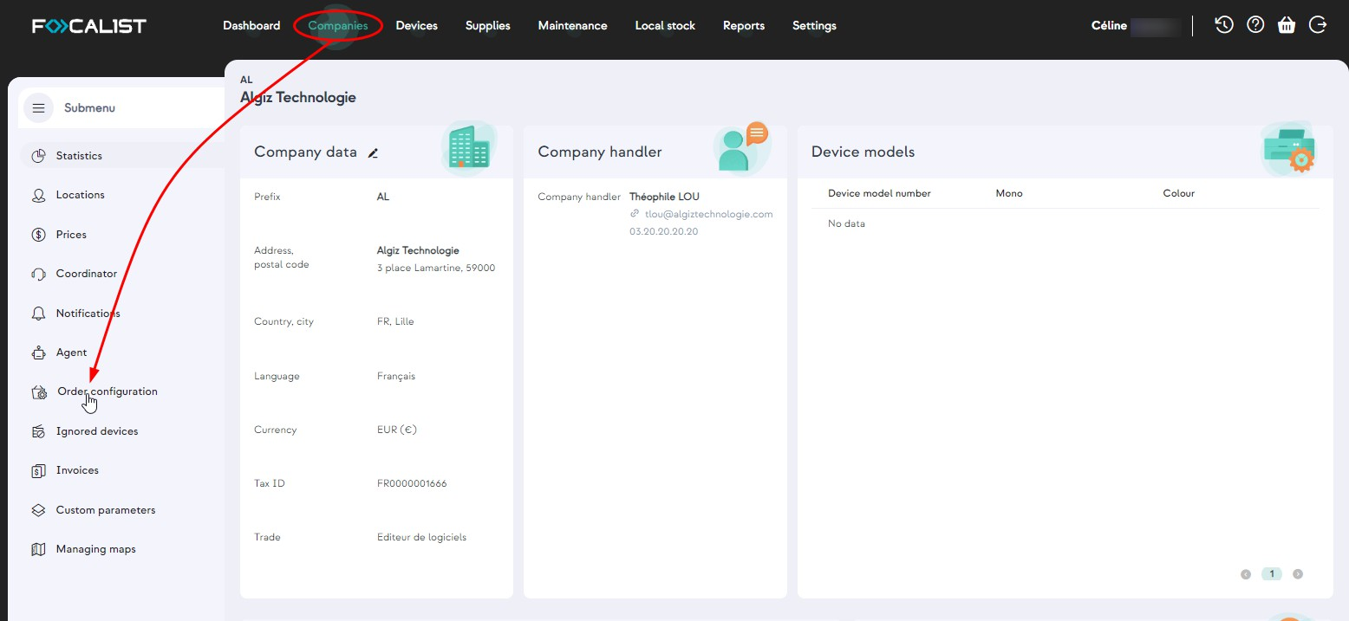

In our system, we offer two effective order conﬁguration methods. The ﬁrst is the "Pro- active" option, which allows the user to specify the number of days expected until the material runs out. Once this estimated time is reached, the system automatically gen- erates an order. Proactive methods can be implemented ONLY for printers that have more than one month of print history. If it is possible, in this method we use the history from 3 months ago, to make predictions.

The second option is "Level", which allows you to set the material inventory limit as a per- centage. When it is achieved or exceeded, the system immediately generates an order, efﬁciently supporting the supply management process. . This ﬂexibility allows you to adapt the ordering process to individual needs and changing business conditions, contributing to efﬁcient supply management.

The order generation view for both conﬁgurations is identical and includes three described sections, which present:

Levels for toners, including:

* mono toners (monochrome)
* color toner

Levels for drums, including:

* Mono drum (monochrome)
* Color drum

Levels for the MK (Maintenance and Key Components) part, including:

* Maintenance materials (among the articles and components that can be found here, we can mention things such as oils, ﬁlters, rollers, transfer tapes, etc.)
* Waste toner

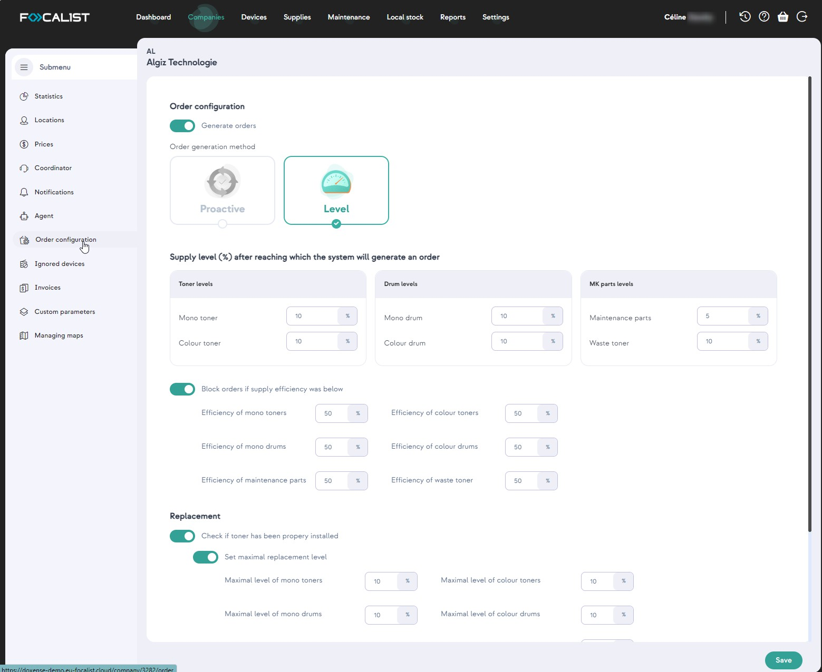

Another important function of the application is the ability to block orders for materials whose efﬁciency is below a certain percentage scale. The user can set the minimum acceptable performance. When a material' s yield drops below this value, the system pre- vents you from placing an order for that material. It is an effective control tool that allows you to avoid ordering inefﬁcient materials, positively affecting the efﬁciency and costs of resources.

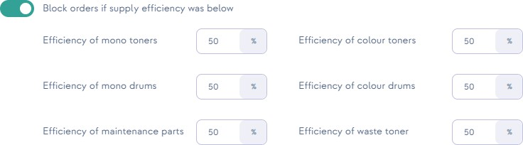

Going to the "Replacement" subtab in the application, an important option appears - activ- ating the alarm in case of improper installation of the material.

With this feature, the user can conﬁgure the system so that if the material is not installed correctly, an alarm will be generated. This is an important safeguard that helps prevent potential problems related to incorrect installation of materials, which could negatively affect the quality of prints and the efﬁciency of the device.

The user also has the option of:

* Maximum level settings as a percentage of when the material should be replaced:
* Activation of the alarm if the new material model does not match the ordered one.
* Activation of the alarm if the material has been replaced from another device.
* We assume that the toner levels below 80% are not new, but have been previously used in another printer (except when a device is added to the system, then the mater- ial level can be any). Additionally, if a serial number is present, we check whether such a number is already in our database.
* Activation of the alarm if there was no previously generated order for the material.

Verify that an order exists for the material before attempting a replacement. If it does not exist, then the alarm is activated.

* Activation of the alarm if the order for the material has not been previously sent.

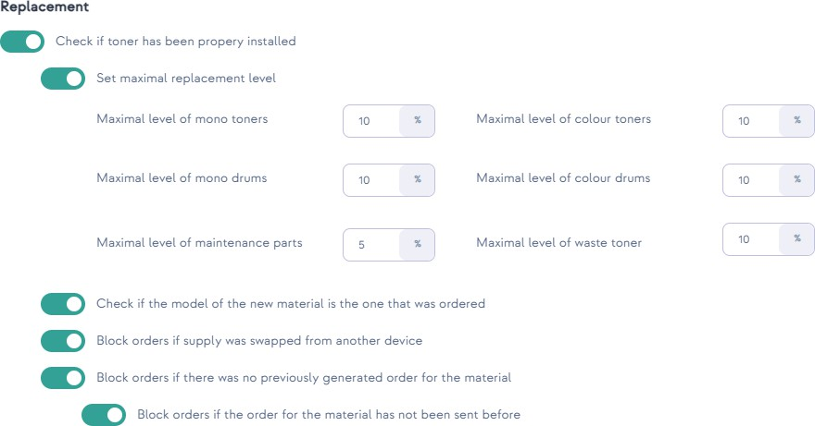

### Ignored devices

In this section are lists of devices marked as ignored which agents ignore during scanning the network. Devices in this list can be only added in the “adding device” window, when you decide to delete them there.

### Invoices

Invoices allow you to monitor customer payments. They are only information so beside dis- playing there then don' t do anything, like sending messages to clients. After clicking the “Add an invoice”, you can write receivables to be paid by the client.

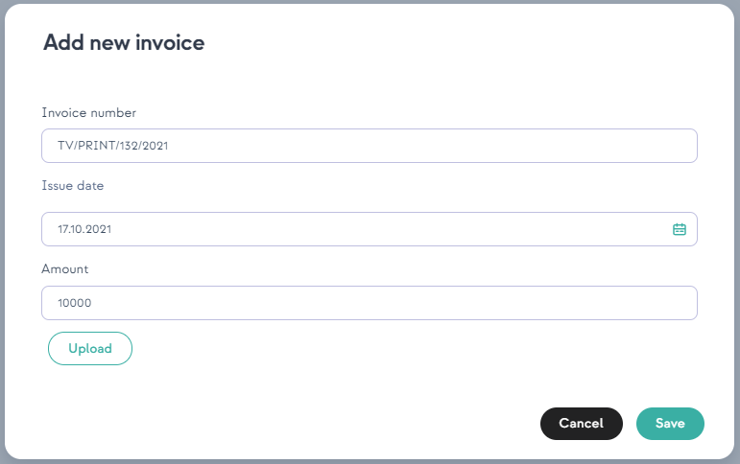

After adding invoices you have 4 potential actions:

* Edit, allow you to edit invoices data and upload file
* Add a payment, the total amount can be paid in installments, so for a better over- view, each payment can be added separately
* Payments, display list of payments for selected invoices
* 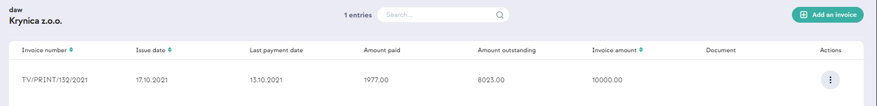Delete, delete invoice from list, all data for this invoice would be lost Invoices record example:

### Other settings

#### Company data

In this label it’s possible to change all company data which you enter during adding com- pany. Such as: Company name, Prefix, Tax ID, Language, Address, Postal code, City, Cur- rency, Country and Trade.

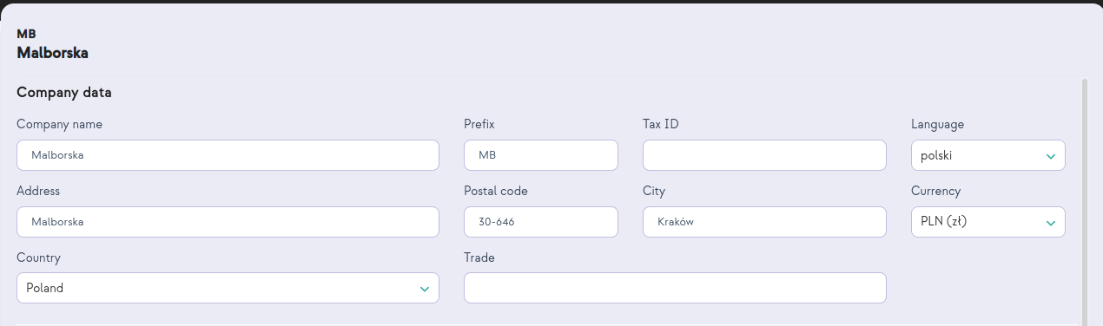

#### Additional settings

The period after the device is marked as not responding (days) - Is a global setting for all devices in a given company after which device would change its status from active to not responding. Not responding is treated like active but with the last record from more than days written in this scope.

#### Dictionaries

Dictionaries are additional information about devices that can be displayed in the tab of selected devices, under the label “Parameters” in the device “General information” tab. Additionally this information is concluded in all lists beside “Companies”.

There are 3 types of Dictionary:

* Text, in this option you write static text for each device while setting the dictionary for the device.
* List, on the other hand, defines a list of text at the moment of creating a dictionary,

and you select one text from the list during the device setting.

* OID is an identifier that is sent to the printer via SNMP to retrieve specific data

# Devices

The Devices tab contains all devices You have added, and displays crucial information about them. Among the non-obvious features that can be seen, and the name of the column does not necessarily say what they mean, you can include:

* Status column provides information about the current status of the device con-

nection with agent and includes four possible options:

* Active
* Not responding
* Inactive
* Deleted
* Lowest supply status column contains information about the status of the supply with the lowest level and includes four possible options:
* Ok
* Low
* Empty
* Unknown
* Connection type column contains information on how to communicate with the device, and includes three possible options:
* LAN - connects using a network agent
* UBS - connects using USB agent
* Unmanaged - stands for an unmanaged device - in other words a manually added device.

Note: To delete device go to the Actions column Advanced search

On the left side there is an advanced search panel where you can search for devices using

the following filters:

* Companies and locations, search using the name of added companys or locations
* Device model number, search using device name and specific device model num- ber
* Coordinator, search using the name of the coordinator, person responsible for a spe-

cific device

* Device

## Device

### General information

To access detailed settings for a specific device, click on its name in the Device ID column. Then a window with general information about the specific device will appear, while on the right you will see the other devices. Detailed information about the device is displayed below, divided into the following columns:

* Parameters information about used dictionaries for this printer, the plus on the right takes you to Device settings.
* Toners and drums
* Maintenance kit/others
* Input tray

### Alerts

The alerts tab is on the left side and it is about device crashes and low supply. Alerts tab displays errors for specific devices.

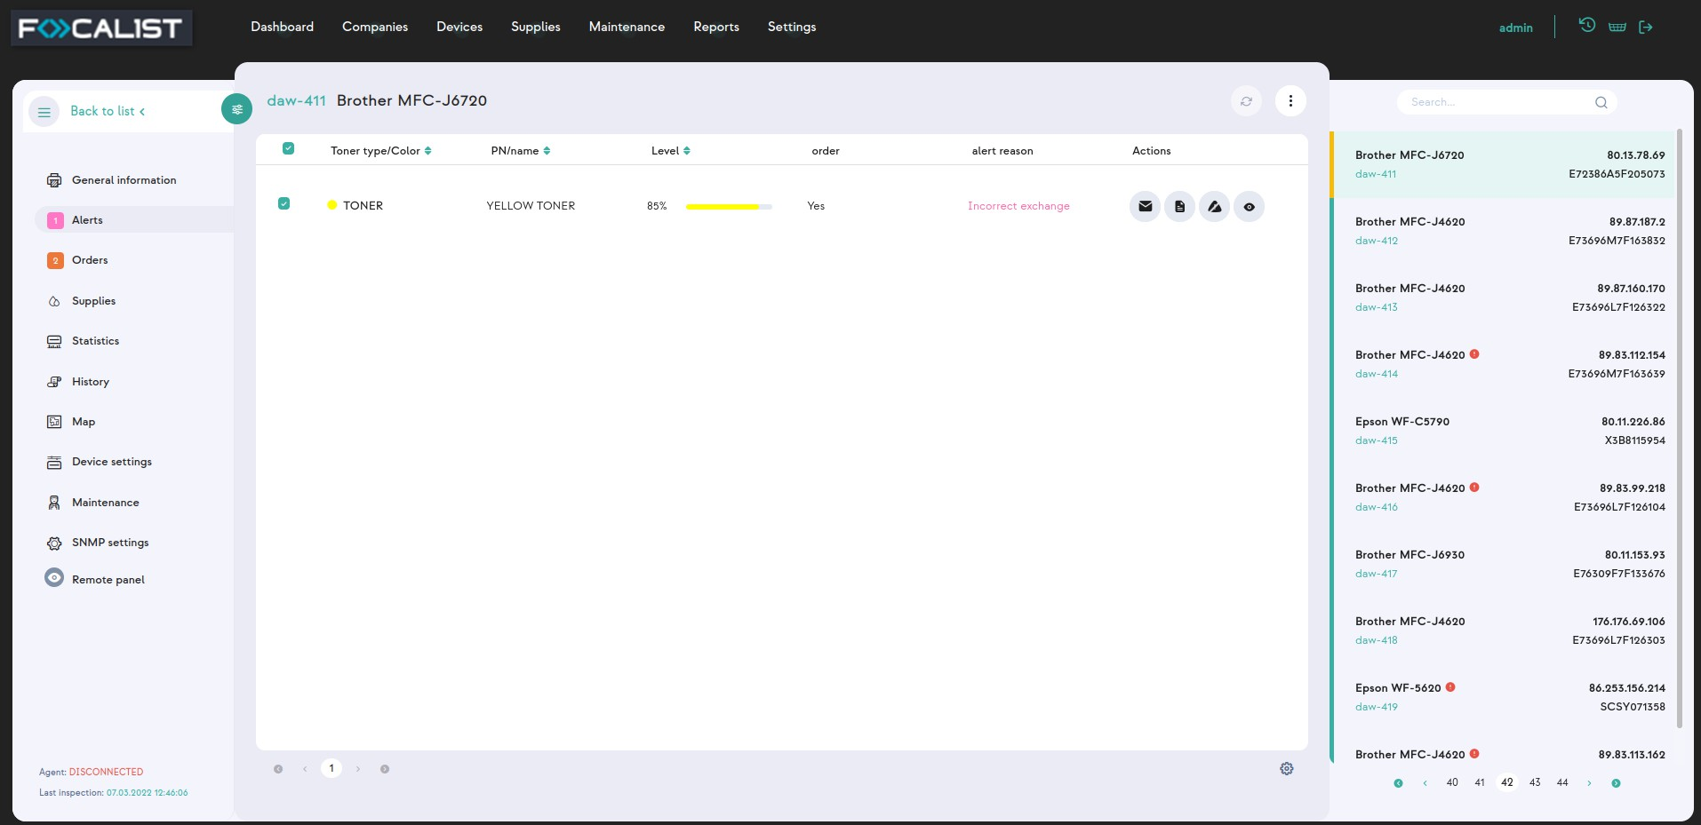

There are four possible action that can be taken with alerts:

* Send email
* Add note, note that
* Ignore alarm,
* Details,

### Orders

Orders is one of main Focalist features, agents at regular, preset intervals, it polls devices for the status of resources. And if they are low on some supply it generates order for that supply. The generated orders are visible in the section also in tab Supplies.

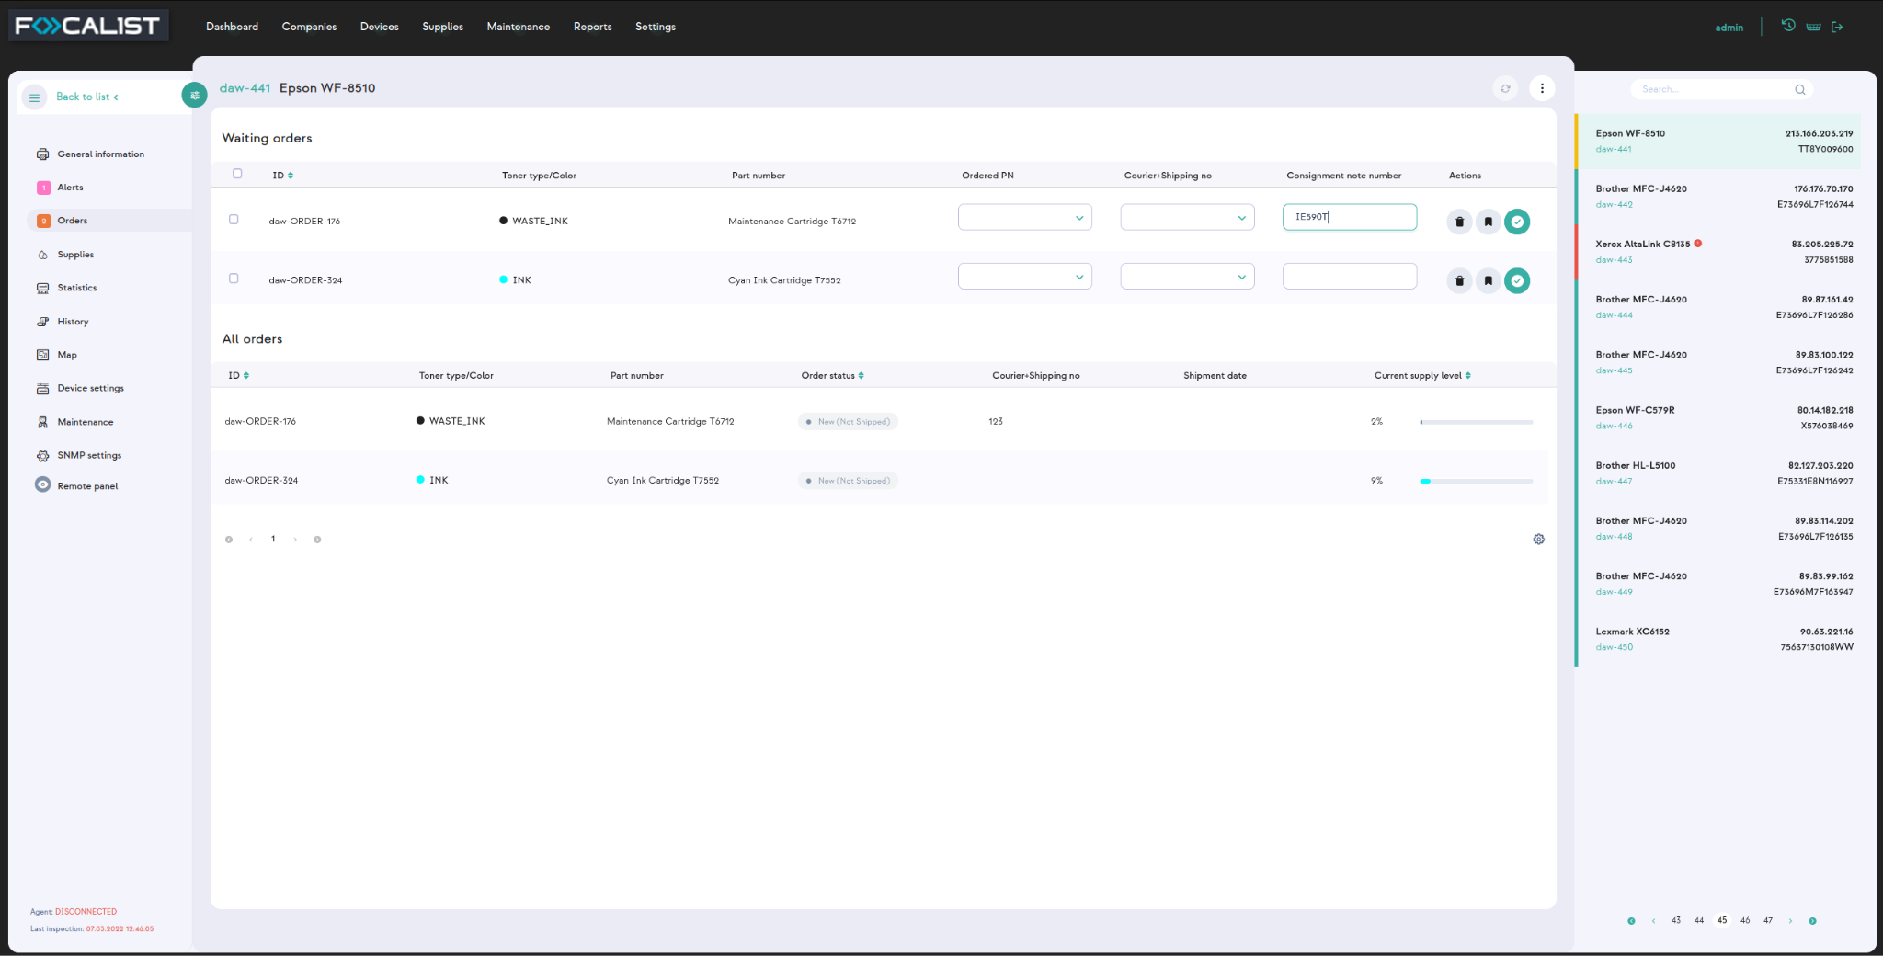

Part number - Information retrieved from device about part number, they can be accurate as on the above screen, but most of the time there is only shor information like

black toner.

Ordered PN - Ordered Part Number, full catalog part name, selected from list that client can enter manually in the settings(Supplies model numbers)

Courier+Shipping no - clue about curier in charge of delivering supplier. Selected from list,

can be added in settings(Couriers).

### Supplies

This tab contains information about supplies installed in the printer. Additionally you can check each supply separately and see statistics about them.

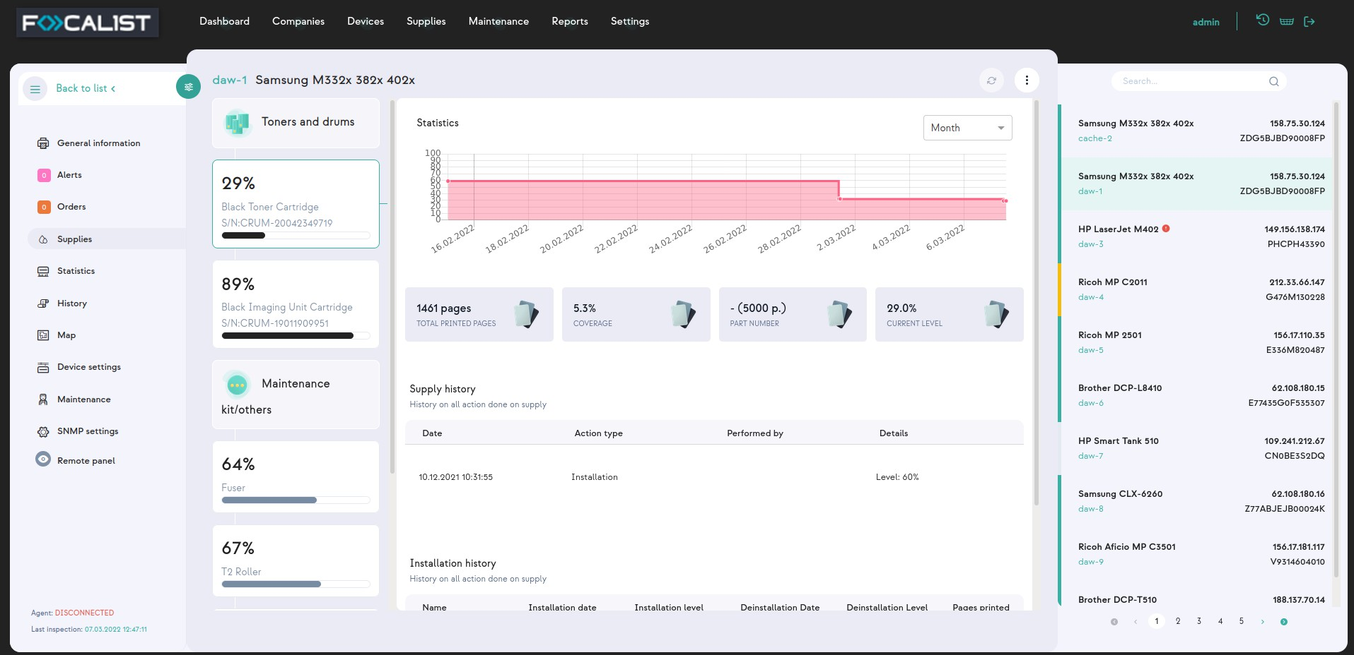

### Statistics

This section contains information about detailed printer statistics. If possible separate prin- ted pages by format(A3, A4,...) and mono/color.

#### How does the Focalist count pages?

This is one of the most frequently asked questions, because there is often a problem that the number of pages in the Focalist app is different from those given by the printer.

At Focalist, we bring the final total result of printed pages to A4. Considering that, Focalist

count pages accordingly:

* A3 and everything bigger than A3 - 2 pages
* All other lower sizes than A3 - 1 page

### History

History section contains information about what has been going on with the device since it was added to the application. The historical information such as error alerts, toner install- ation or Device activation in chosen location.

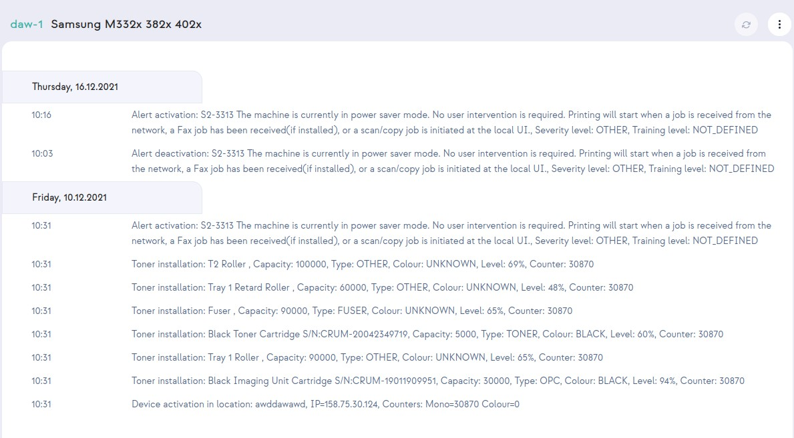

### Map

This tab is really useful in case of many devices installed in different locations. You can add information about device location with an image of a map where the device is placed.

### Device settings

Additional parameters

Information that are displayed In tab Devices and are included in generated reports under section Parameters.

Location

You can select here information about where the device is installed. It would affect future reports.

Coordinator

By default is assigned the one in charge of the location where the device is installed, but it can be changed here.

Reports

Include or not printer in reports.

Order settings

Option for customizing the generation of orders for chosen devices.

Price settings

Custom settings for prices, only available if chosen if Advanced billing method is chosen to be “The custom price for the device model”.

### Maintenance

In this tab you can submit a new maintenance request and assign someone or edit an exist- ing one. All created requests would be visible in the Maintenance tab. It is only visual information, to better organize work.

### SNMP settings

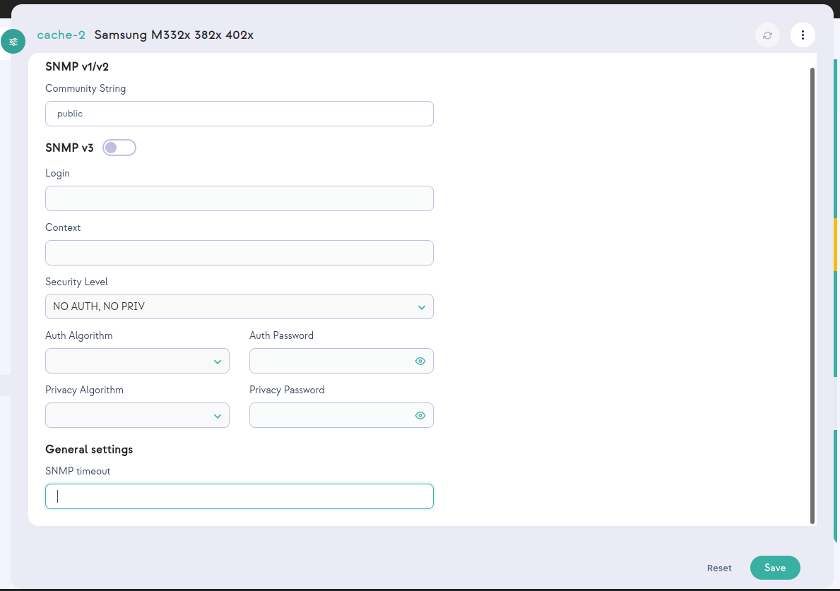In this tab you can set configuration data for SNMP. In versions v1 and v2, it is enough to configure one parameter: Community String. In the case of the v3 version, more para- meters must be given for authorization.

### Remote panel

This option isn’t available by default, so customers need to make a support request to unlock it. Additionally, the Agent by through the printer is added. Need to have unlocked this option. You can unlock the agent by adding line remotePanel=true to the file agent.- config at directory config/ on the place where agent was installed. If the file doesn' t exist, you need to create it and add that one line there.

When it’s available it allows remote access to the device panel outside of the local network

where the device is installed. Agent and Server applications work as proxy to local devices, for this reason it’s locked by default.

# Supplies management

### What is supply management in Focalist:

* A complete set of capabilities that automates fulfillment / replenishment of supply- items for a managed fleet of devices
* Detection of supply-items nearing the end-of-life
* Proactive recommendation for shipments before the actual end-of-life
* Detection of exceptions and workflow of associated approval processes
* Links to, and administration of, back-end fulfillment/delivery processes
* Management of supplies catalog (replacement supply-items) and fulfillment pro- viders (supplies reseller/distributors)

### What is toner fulfillment process:

* A complete set of capabilities that automates replenishment of toner cartridges for a managed fleet of devices
* Detection of toner cartridges that are getting close to empty

(low toner cartridge, maintenance items, etc.)

* Proactive recommendation for shipping new cartridges before the existing ones are out of toner
* Detection of exception and workflow of associated approval processes
* Links to, and administration of, back-end fulfillment/delivery processes
* Management of toner cartridge catalog (replacement cartridges) and fulfillment pro- viders (supplies resellers)

### Adding supply (first supply installation)

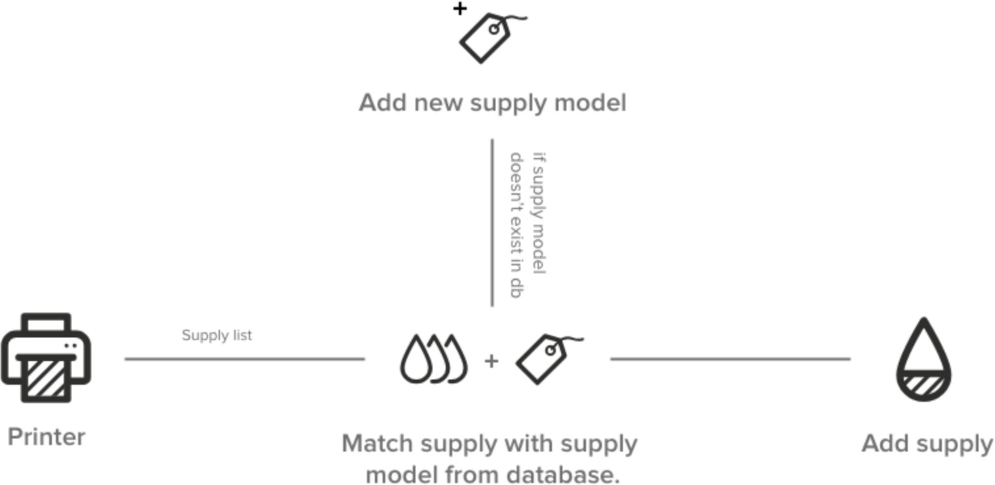

1. Focalist scans the devices and downloads information about the installed supply from the printer. The following is downloaded: serial number, performance catalog number, level.

Note: Not all data are available from all devices. In some cases printer don’t give capacity or exact level.

1. Focalist checks if the model of the installed material is already in the base. If it is not present, a new material will be added.

Possible Alarms

Damaged supply - Focalist can detect that the supply installed in the device returns an incorrect value and is most likely damaged. If such a situation occurs on the material, the alarm will be added: Damaged material

### Inspection of supply status:

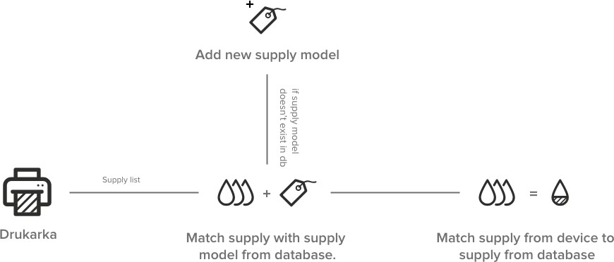

### Supply replacement

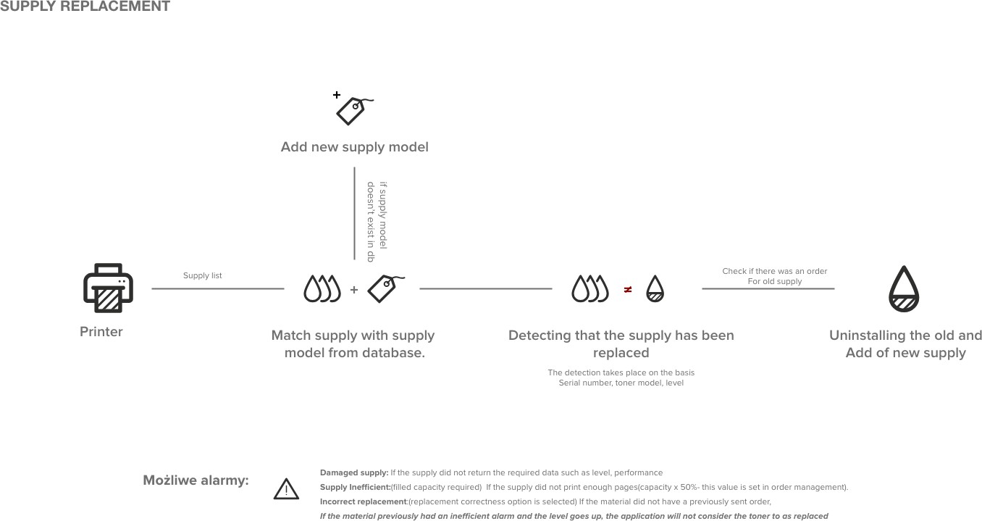

### Adding order automatically

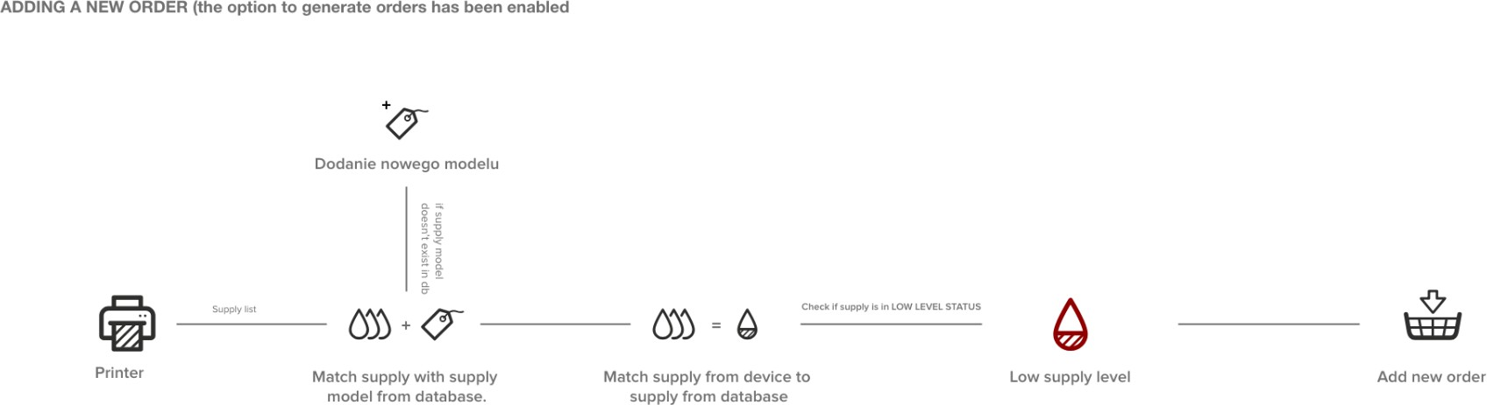

## Alerts

List of alerts generated by Focalist. If option Companies > chosen company > Order con- figuration > Check if the toner has been properly installed is enabled, then on unsolved

alerts order would be blocked.

### Alert list:

**Unknown level**

Indicates that material was not updated in the last inspection due to problems with data retrieved from the printer. We were unable to determine the material it was related to.

**Toner inefficient**

The toner yield is less than assumed in Companies > chosen company > Order con- figuration > Block order for a toner, if its efficiency is lower than (%).

**Incorrect exchange**

There are several cases that may cause incorrect exchange:

* There was no order.
* The order was but was not in "Installation in progress" status.
* The new material has a level of less than 80%.
* The material with the given serial number has already been installed somewhere.
* The material was replaced before it reached the replacement level (this is con- figurable in orders).
* The model of the material that was ordered does not match the model that was inser-

ted into the printer.

**Not updated**

Indicates that material was not updated in the last inspection due to problems with data retrieved from the printer.

## Waiting orders

In this section You can asing additional information to your order and mark it as sent or deleted.

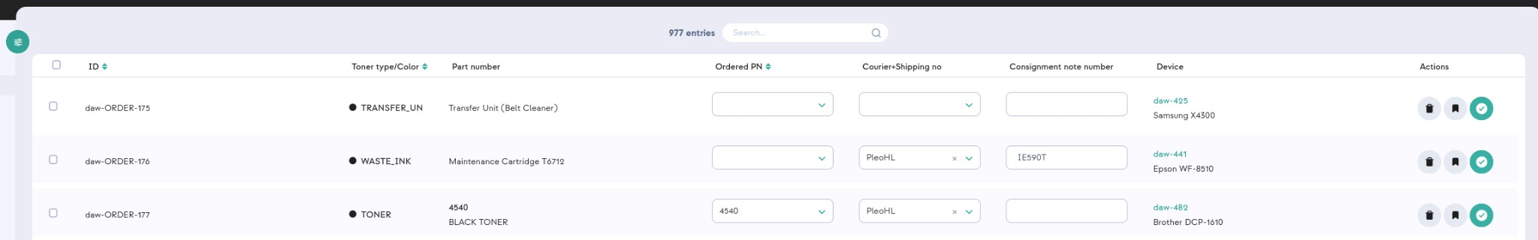

**Order PN**

Full name ‘Order Part Number’, resource catalog number, sometimes different from those returned by the printer, the printer often returns only color It can be added in Settings > Supplies model numbers.

**Courier+Shipping no**

You can add a person responsible for delivering the missing resource to the final des- tination. . They can be added in Settings > Couriers.

**Consignment note number**

Additional note added to order.

## All orders

Overview list of all orders generated by the app. Containing both historical and currently processed entries, sorted by default by the ‘Shipment date’ column.

## All supplies

List of all supplies that can be detected from printers. For each element, there is inform- ation about the resource, device and company in which it is located. Additionally , there is information about last order status as well as date of first detection of supplies in the printer (Installation date).

Level shows level from last detection, if you want to check

Additionally you can click the action button ‘Details’ to check how the toner consumption has changed over the last week, month or year. The change of resources would be shown in different colors as in screen below.

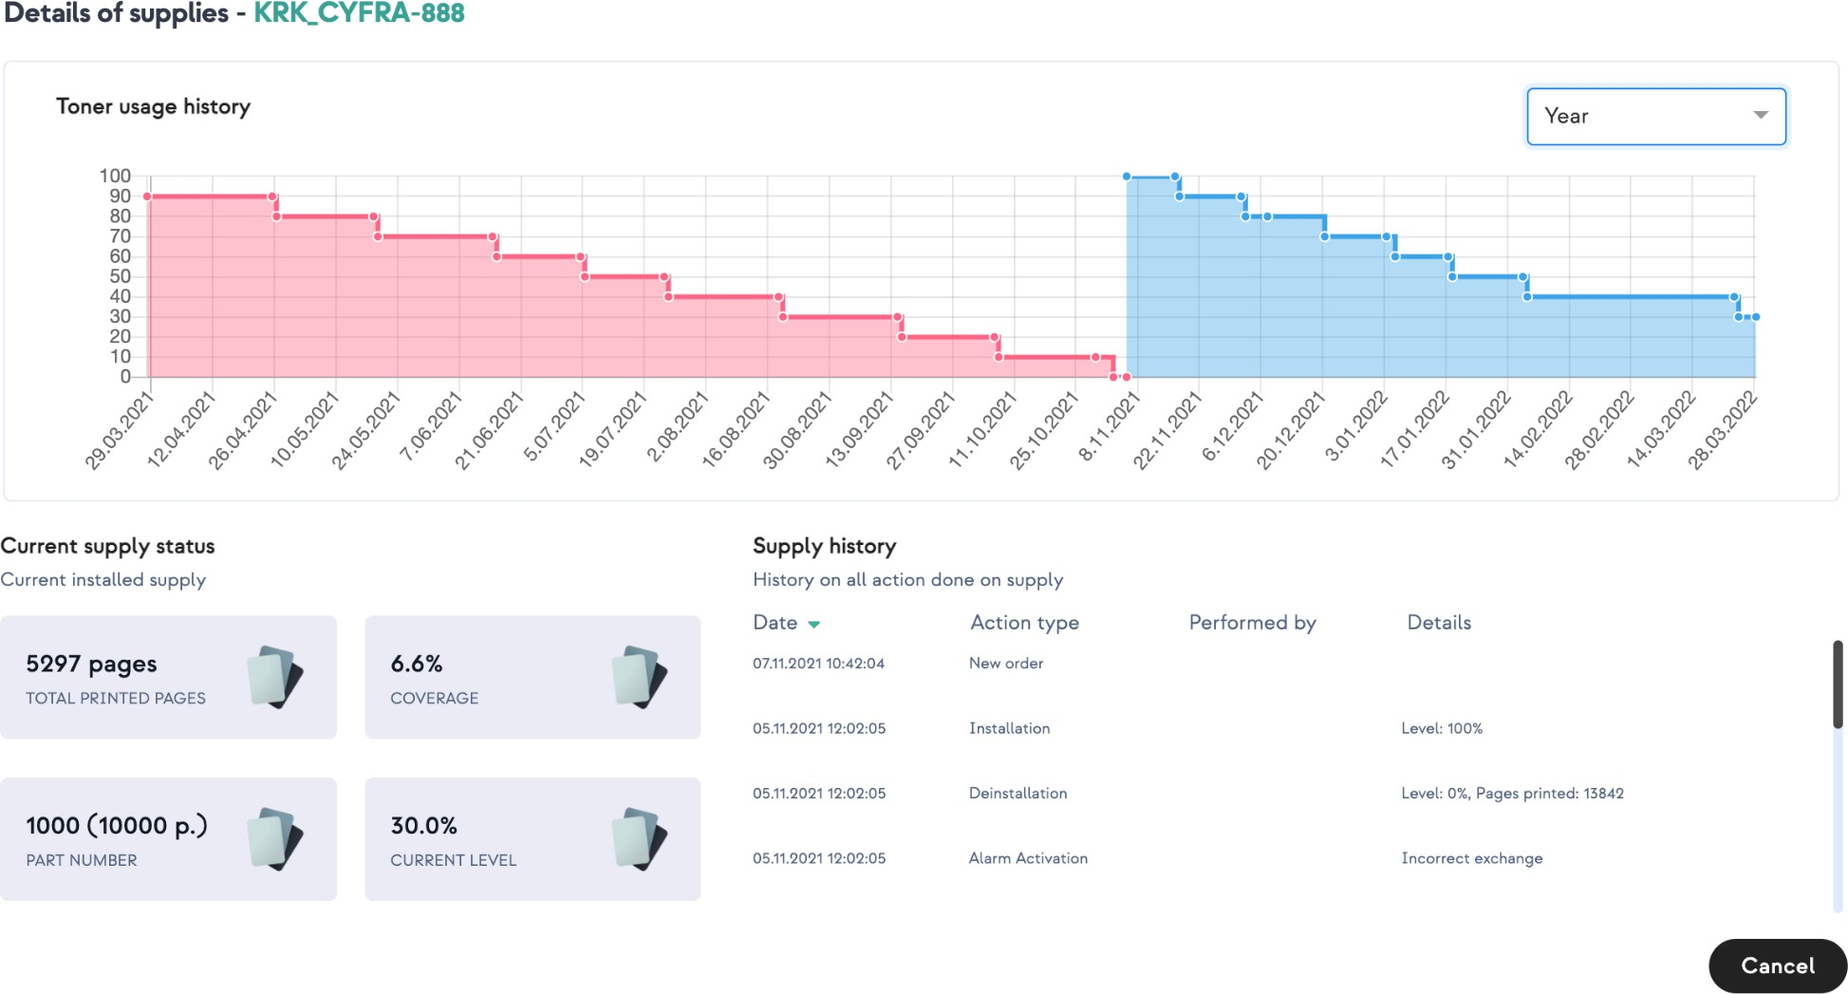

# Maintenance

## Active errors

There is a list here that contains information about the detected errors and deficiencies dir- ectly related to the device. Which has not been handled yet. Errors that appear here are automatically generated by the application. They are called SNMP alerts.

Under the Description column there is a message that contains two parts. One on top is information fetched from the device about the problem. Bottom one is the degree of dif- ficulty of the problem which is divided into:

* untrained - not require trained personnel
* trained - need to be technical one
* engineer - require service man

From the Active Errors tab you can assign someone to take care of a problem by clicking the action button “Transform”.

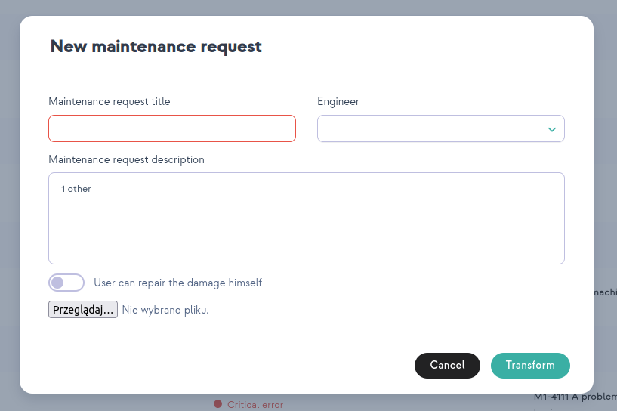

Engineer is the person In charge of the Company where the device is installed and has the role Engineer.

## Repaired

Same as with the above active errors, these with repaired status are also sent auto- matically by the devices, also in the form of SNMP alerts. We show all of them in this sec- tion.

## Maintenance request

Active errors can be transformed into Maintenance requests, it’s recommended to use it on more complex errors requiring a technician or engineer. The advantage of using this function is the ability to accurately track the error , its current status, and the ability to add comments to a specific problem.

There are five error statuses which are as follows:

1. Unsolved - new request, to start working on it you select ‘Start request’ from action buttons.
2. In progress - in the course of work on the error request.
3. Done - problem set as resolved by worker.
4. Solved - admin confirms that tasks have been correctly resolved.
5. Declined - admin decline task.

## Reset password

1. To reset your account password, click the following link : [https://management.eu-focalist.cloud/password-reset/yPh-](https://management.eu-focalist.cloud/password-reset/yPhsTCrpooe7V0AHjPPH28F6RsXSmJne) [sTCrpooe7V0AHjPPH28F6RsXSmJne](https://management.eu-focalist.cloud/password-reset/yPhsTCrpooe7V0AHjPPH28F6RsXSmJne)
2. 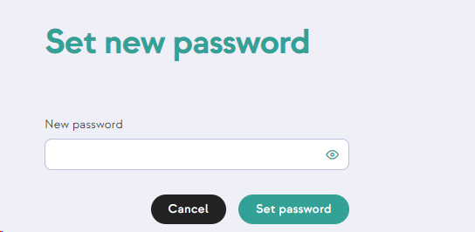enter your new password in the field:
3. click **Set password**.

# Reports

Reports are statistical information that can be generated based on information collected by Focalist. They can be saved as CSVor XLSX.

Each report can be downloaded instantly. To do it you have to click the Actions button

with a miniature of the eye. Then select the companies you want to cover. In order to finally download the report, select CSVor XLSX in the upper right corner (Generating the report may take a while, changing the color of the inscription to light gray means that the gen- eration process has started, when it is finished, it will return to the normal color).

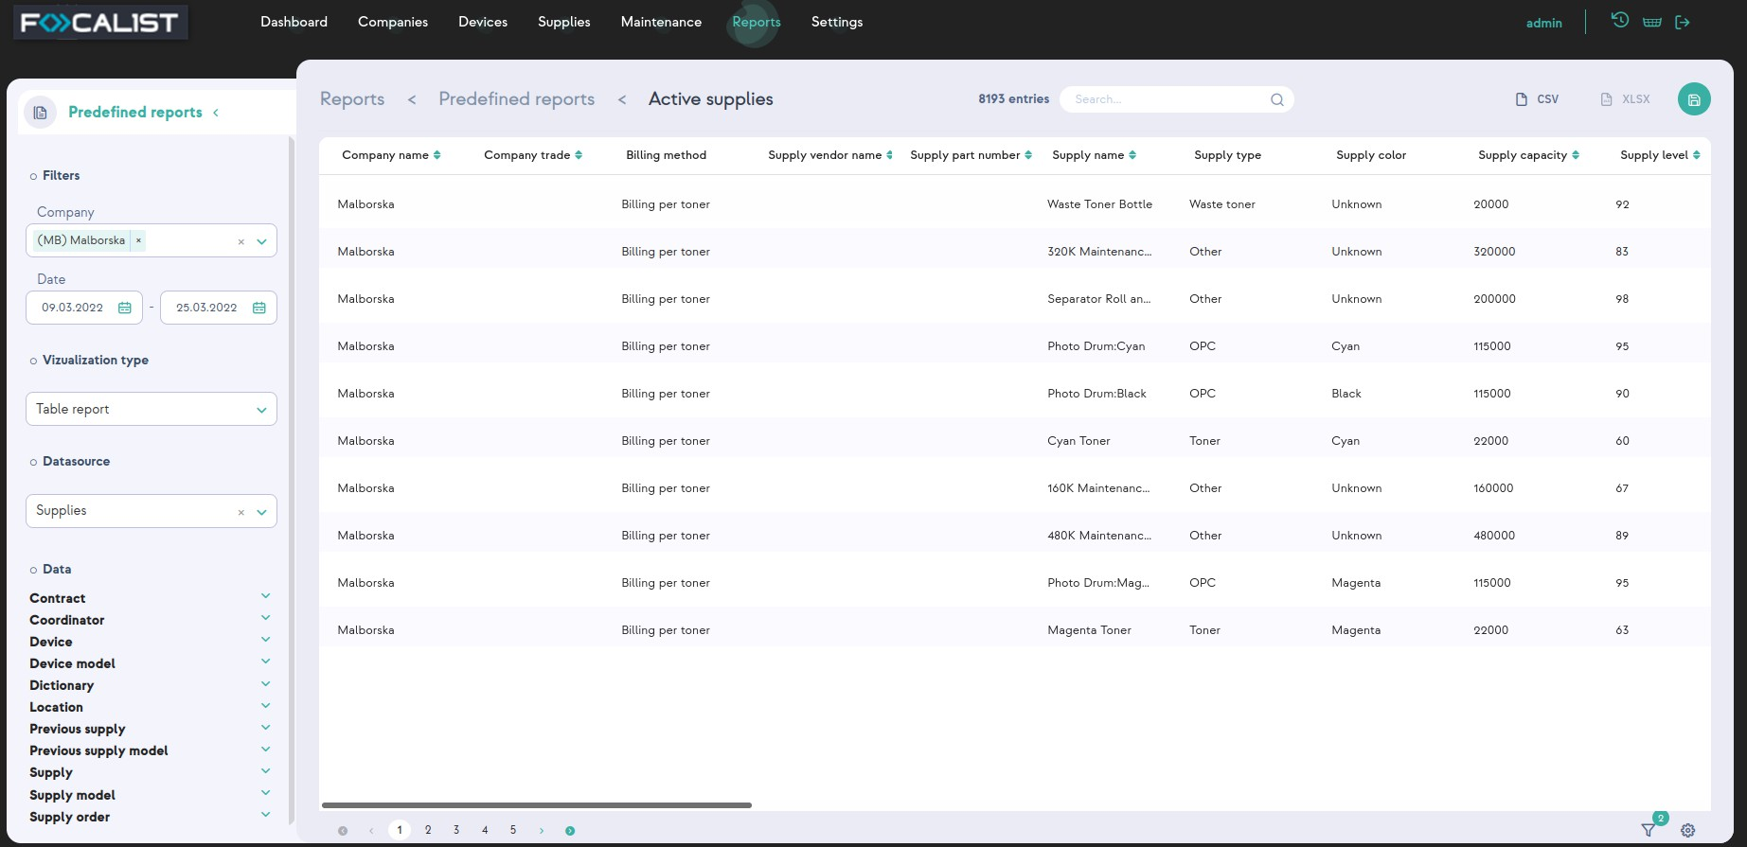

In addition to the possibility of downloading reports from the application, it is also possible to set a scheduler for sending reports via email, for chosen persons. It can be done by click- ing the action button with the symbol of the clock.

Detailed information about adding schedulers are described in section Report schedule.

## Predefined reports

The reports here are prepared top-down by the Focalist team. They contain sets of data collected in the form of reports that are most often used by customers. It was created based on our experience and numerous consultations with clients and their needs. These reports are non-editable and indelible, the only customization option is to create your own report based on them.

## List of your reports

Customized reports created by users. They are the same as predefined reports, the only difference is that they can be deleted and they can be made as private reports. The private reports will not be seen by other accounts.

## Create your own report

You can create your own reports in this section, you have two options: Use the wizard to create a report

For new users it is recommended to use this option, by choosing it, the application step by step will ask you for information that you want to be implemented in the report.

Create report manually

With this option you are automatically moved to the customization panel, it’s recom- mended to use this by more experienced users.

## Report schedule

You can set a scheduler that would send chosen reports at regular intervals of time to email. To add a scheduler you have to click the button ‘Create report schedule’ that is placed in the right corner.

At the first step You have to set the scheduler name, choose report and frequency.

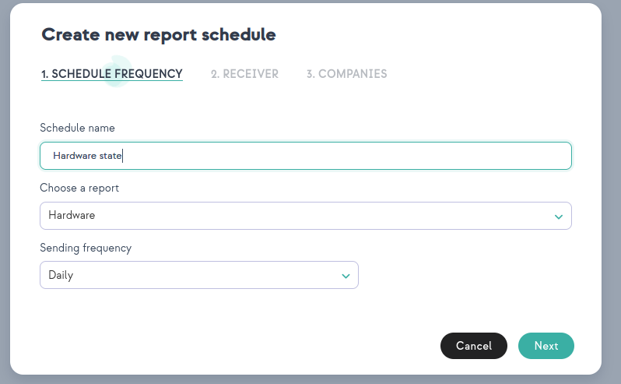

Secondly you set receiver of email and chose type of document (CSV or XLSX)

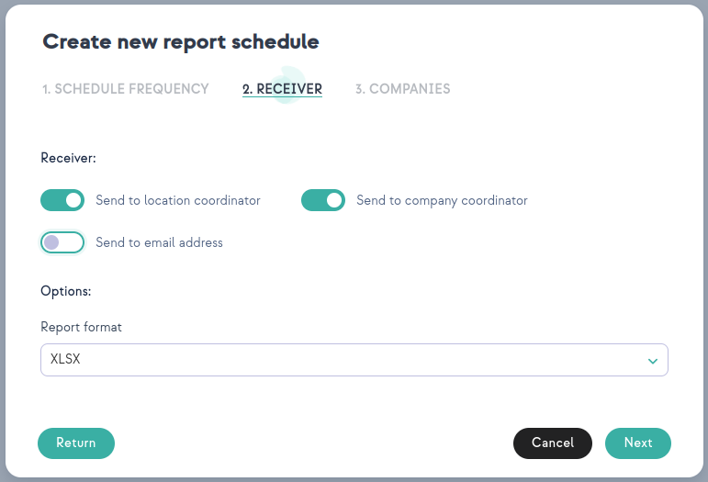

Finally you choose companies from which you want to get information that would be included in reports.

# Settings

In the settings tab, depending on the permissions you have, specific tabs are displayed.

## Account

In the account tab, you can change the username, email address and password assigned to the account. It is also possible to change the language of the Focalist application.

Application Access Key is used to get access to Focalist rest api.

## License

The licenses tab contains information about the license expiry date. In order to extend the license you need to:

* If you are using Focalist installed on our server, send an email with a request for extension to the address [focalist@doxense.zendesk.com](mailto:support@princity.com), and after approval by sup- port, the license will be automatically renewed.
* If you are a onesite client send an email with partner id to the address [focal-](mailto:support@princity.com) [ist@doxense.zendesk.com](mailto:support@princity.com), after receiving the return email with the license, enter it in the upload a license tab.

## Users

In the Users tab you can set whether the user should be active or not. In this tab you can assign user specific roles - users will have access to selected units in the app, depending on the role.

Note: If your account is blocked due to an unsuccessful login attempt, the Administrator needs to activate the account in this tab.

## Profiles

You can add new account types in this tab, as well as change permissions for the one that already exists. Different permissions determine how many things from the application they can see and edit.

Note: SERVICEMAN on login has by default another panel called "Engineer Panel", which allows him to see only information about attached requests to him.

## Appearance

In the appearance tab, you have the option to change the logo visible in the upper left corner, and the email address that will be visible as the sender of outgoing messages from the system. You can also change the new user default language.

## Supplies model numbers

In this tab, you can add for each exchangeable type of resource, its part number and the supplier(Toner manufacturer) from which the resource is bought.

## System options

Focalist default options that can be disable if needed.

Launch an automatic network search after the agent' s first connection

Start scanning on successful first agent connections. With this option disabled you have to scan manually from agent look, or wait till the first scheduler starts scanning.

It can be useful when you are installing an agent in a location from which you will be moving

devices soon and don' t want to add them.

Keep location on device IP change

This is a feature to keep location for devices on IP change. If this option is disable, then for example if DHCP changes the IP address of the printer you will have to add again location for that printer.

On device detection deactivate this device in other companies

If you move a device from company A to company B, by default the device would be deac- tivated in company A. With this you can safely add devices to the B company. Without this option enabled you will have 2 active devices in two different companies. From which, one printer will constantly generate errors. So you will have to personally deactivate that printer.

## Notification

In the notifications tab, you can change the settings for sent notifications.

It is possible to set whether notifications should be sent, to whom and in what frequency.

## Order configuration

Default configuration for orders, that can be customized for each company. They are exactly the same as one in Company > Order configuration.

## Couriers

This tab shows couriers that can be added when ordering. Information about couriers is also visible in the tab Supply > Waiting orders and also in tab Device > Orders.

## Supplies manufactures

During adding new supplies in Supplies model numbers, you can choose ‘Toner man- ufacturer’ from the list. They are added in this tab. This is a friendly way to write down a list of resource vendors for your business. Thanks to this, in the lack of a given resource, you quickly know who to contact to obtain more.

## Currencies

Focalist is an international solution supporting the management of a fleet of printers. There- fore, in addition to the possibility of choosing the language, we also allow you to add your own currency, which will be displayed in the application and reports.

# Troubleshooting- Hewlett Packard devices - Invalid Certificate

## Context

It occurs that some Hewlett Packard devices are unreachable.

However, we can verify that the Focalist Agent is installed and connected.

## Cause

The Agent cannot access the HP device web page (EWS) due to an invalid certificate. This is used to read counters with the default policy HP_FUTURE_SMART.

## Resolution

It is advisable to proceed to a meter reading in pure SNMP by changing the strategy to HP_LASERJET_ACCOUNTING.